Python questions for data scientist and software engineers
Source: https://towardsdatascience.com/53-python-interview-questions-and-answers-91fa311eec3f?gi=1949d82e9cb7

1. What is the difference between a list and a tuple?
- Lists are mutable. They can be modified after creation.
- Tuples are immutable. Once a tuple is created it cannot by changed
- Lists have order. They are an ordered sequences, typically of the same type of object. Ie: all user names ordered by creation date, ["Seth", "Ema", "Eli"]
- Tuples have structure. Different data types may exist at each index. Ie: a database record in memory, (2, "Ema", "2020–04–16") # id, name, created_at

2. How is string interpolation performed?
Without importing the Template class, there are 3 ways to interpolate strings.
name = 'Chris' # 1. f strings
print(f'Hello {name}') # 2. % operator
print('Hey %s %s' % (name, name)) # 3. format
print(
"My name is {}".format((name))
)

3. What is the difference between “is” and “==”?
Early in my python career I assumed these were the same… hello bugs. So for the record, is checks identity and == checks equality.
We’ll walk through an example. Create some lists and assign them to names. Note that b points to the same object as a in below.
a = [1,2,3]
b = a
c = [1,2,3]
Check equality and note they are all equal.

print(a == b)
print(a == c)
#=> True
#=> True
But do they have the same identity? Nope.
print(a is b)
print(a is c)
#=> True
#=> False
We can verify this by printing their object id’s.
print(id(a))
print(id(b))
print(id(c))
#=> 4369567560
#=> 4369567560
#=> 4369567624
c has a different id than a and b.

4. What is a decorator?
Another questions I’ve been asked in every interview. It’s deserves a post itself, but you’re prepared if you can walk through writing your own example.
A decorator allows adding functionality to an existing function by passing that existing function to a decorator, which executes the existing function as well as additional code.
We’ll write a decorator that that logs when another function is called.
Write the decorator function. This takes a function, func, as an argument. It also defines a function, log_function_called, which calls func() and executes some code, print(f'{func} called.'). Then it return the function it defined
def logging(func):
def log_function_called():
print(f'{func} called.')
func()
return log_function_called

Let’s write other functions that we’ll eventually add the decorator to (but not yet).

def my_name():
print('chris')def friends_name():
print('naruto')my_name()
friends_name()
#=> chris
#=> naruto

Now add the decorator to both.

@logging
def my_name():
print('chris')@logging
def friends_name():
print('naruto')my_name()
friends_name()
#=> <function my_name at 0x10fca5a60> called.
#=> chris
#=> <function friends_name at 0x10fca5f28> called.
#=> naruto
See how we can now easily add logging to any function we write just by adding @logging above it.

5. Explain the range function
Range generates a list of integers and there are 3 ways to use it.
The function takes 1 to 3 arguments. Note I’ve wrapped each usage in list comprehension so we can see the values generated.
range(stop) : generate integers from 0 to the “stop” integer.
[i for i in range(10)]
#=> [0, 1, 2, 3, 4, 5, 6, 7, 8, 9]
range(start, stop) : generate integers from the “start” to the “stop” integer.
[i for i in range(2,10)]
#=> [2, 3, 4, 5, 6, 7, 8, 9]
range(start, stop, step) : generate integers from “start” to “stop” at intervals of “step”.
[i for i in range(2,10,2)]
#=> [2, 4, 6, 8]
Thanks Searge Boremchuq for suggesting a more pythonic way to do this!
list(range(2,10,2))
#=> [2, 4, 6, 8]

6. Define a class named car with 2 attributes, “color” and “speed”. Then create an instance and return speed.
class Car :
def __init__(self, color, speed):
self.color = color
self.speed = speedcar = Car('red','100mph')
car.speed
#=> '100mph'

7. What is the difference between instance, static and class methods in python?
Instance methods : accept self parameter and relate to a specific instance of the class.
Static methods : use @staticmethod decorator, are not related to a specific instance, and are self-contained (don’t modify class or instance attributes)
Class methods : accept cls parameter and can modify the class itself
We’re going to illustrate the difference around a fictional CoffeeShop class.
class CoffeeShop:
specialty = 'espresso'
def __init__(self, coffee_price):
self.coffee_price = coffee_price
# instance method
def make_coffee(self):
print(f'Making {self.specialty} for ${self.coffee_price}')
# static method
@staticmethod
def check_weather():
print('Its sunny') # class method
@classmethod
def change_specialty(cls, specialty):
cls.specialty = specialty
print(f'Specialty changed to {specialty}')
CoffeeShop class has an attribute, specialty, set to 'espresso' by default. Each instance of CoffeeShop is initialized with an attribute coffee_price . It also has 3 methods, an instance method, a static method and a class method.
Let’s initialize an instance of the coffee shop with a coffee_price of 5. Then call the instance method make_coffee.
coffee_shop = CoffeeShop('5')
coffee_shop.make_coffee()
#=> Making espresso for $5
Now call the static method. Static methods can’t modify class or instance state so they’re normally used for utility functions, for example, adding 2 numbers. We used ours to check the weather.Its sunny. Great!
coffee_shop.check_weather()
#=> Its sunny
Now let’s use the class method to modify the coffee shop’s specialty and then make_coffee.
coffee_shop.change_specialty('drip coffee')
#=> Specialty changed to drip coffeecoffee_shop.make_coffee()
#=> Making drip coffee for $5
Note how make_coffee used to make espresso but now makes drip coffee!

8. What is the difference between “func” and “func()”?
The purpose of this question is to see if you understand that all functions are also objects in python.
def func():
print('Im a function')
func
#=> function __main__.func>func()
#=> Im a function
func is the object representing the function which can be assigned to a variable or passed to another function. func() with parentheses calls the function and returns what it outputs.

9. Explain how the map function works
map returns a map object (an iterator) which can iterate over returned values from applying a function to every element in a sequence. The map object can also be converted to a list if required.
def add_three(x):
return x + 3li = [1,2,3][i for i in map(add_three, li)]
#=> [4, 5, 6]

Above, I added 3 to every element in the list.
A reader suggested a more pythonic implementation. Thanks Chrisjan Wust !

def add_three(x):
return x + 3li = [1,2,3]
list(map(add_three, li))
#=> [4, 5, 6]

10. Explain how the reduce function works
This can be tricky to wrap your head around until you use it a few times.
reduce takes a function and a sequence and iterates over that sequence. On each iteration, both the current element and output from the previous element are passed to the function. In the end, a single value is returned.
from functools import reducedef add_three(x,y):
return x + yli = [1,2,3,5]reduce(add_three, li)
#=> 11
11 is returned which is the sum of 1+2+3+5.

11. Explain how the filter function works
Filter literally does what the name says. It filters elements in a sequence.
Each element is passed to a function which is returned in the outputted sequence if the function returns True and discarded if the function returns False.

def add_three(x):
if x % 2 == 0:
return True
else:
return Falseli = [1,2,3,4,5,6,7,8][i for i in filter(add_three, li)]
#=> [2, 4, 6, 8]
Note how all elements not divisible by 2 have been removed.

12. Does python call by reference or call by value?
Be prepared to go down a rabbit hole of semantics if you google this question and read the top few pages.
In a nutshell, all names call by reference, but some memory locations hold objects while others hold pointers to yet other memory locations.
name = 'object'
Let’s see how this works with strings. We’ll instantiate a name and object, point other names to it. Then delete the first name.
x = 'some text'
y = x
x is y #=> Truedel x # this deletes the 'a' name but does nothing to the object in memoryz = y
y is z #=> True
What we see is that all these names point to the same object in memory, which wasn’t affected by del x.
Here’s another interesting example with a function.
name = 'text'def add_chars(str1):
print( id(str1) ) #=> 4353702856
print( id(name) ) #=> 4353702856
# new name, same object
str2 = str1
# creates a new name (with same name as the first) AND object
str1 += 's'
print( id(str1) ) #=> 4387143328
# still the original object
print( id(str2) ) #=> 4353702856
add_chars(name)
print(name) #=>text
Notice how adding an s to the string inside the function created a new name AND a new object. Even though the new name has the same “name” as the existing name.

13. How to reverse a list?
Note how reverse() is called on the list and mutates it. It doesn’t return the mutated list itself.
li = ['a','b','c']print(li)
li.reverse()
print(li)
#=> ['a', 'b', 'c']
#=> ['c', 'b', 'a']

14. How does string multiplication work?
Let’s see the results of multiplying the string ‘cat’ by 3.
'cat' * 3
#=> 'catcatcat'
The string is concatenated to itself 3 times.

15. How does list multiplication work?
Let’s see the result of multiplying a list, [1,2,3] by 2.
[1,2,3] * 2
#=> [1, 2, 3, 1, 2, 3]
A list is outputted containing the contents of [1,2,3] repeated twice.

16. What does “self” refer to in a class?
Self refers to the instance of the class itself. It’s how we give methods access to and the ability to update the object they belong to.
Below, passing self to __init__() gives us the ability to set the color of an instance on initialization.
class Shirt:
def __init__(self, color):
self.color = color
s = Shirt('yellow')
s.color
#=> 'yellow'

17. How can you concatenate lists in python?
Adding 2 lists together concatenates them. Note that arrays do not function the same way.
a = [1,2]
b = [3,4,5]a + b
#=> [1, 2, 3, 4, 5]

18. What is the difference between a shallow and a deep copy?
We’ll discuss this in the context of a mutable object, a list. For immutable objects, shallow vs deep isn’t as relevant.
We’ll walk through 3 scenarios.
i) Reference the original object. This points a new name, li2, to the same place in memory to which li1 points. So any change we make to li1 also occurs to li2.

li1 = [['a'],['b'],['c']]
li2 = li1li1.append(['d'])
print(li2)
#=> [['a'], ['b'], ['c'], ['d']]
ii) Create a shallow copy of the original. We can do this with the list() constructor, or the more pythonic mylist.copy()A shallow copy creates a new object, but fills it with references to the original. So adding a new object to the original collection, li3, doesn’t propagate to li4, but modifying one of the objects in li3 will propagate to li4.
li3 = [['a'],['b'],['c']]
li4 = list(li3)li3.append([4])
print(li4)
#=> [['a'], ['b'], ['c']]li3[0][0] = ['X']
print(li4)
#=> [[['X']], ['b'], ['c']]
iii) Create a deep copy. This is done with copy.deepcopy(). The 2 objects are now completely independent and changes to either have no effect on the other.
import copyli5 = [['a'],['b'],['c']]
li6 = copy.deepcopy(li5)li5.append([4])
li5[0][0] = ['X']
print(li6)
#=> [['a'], ['b'], ['c']]

19. What is the difference between lists and arrays?
Note: Python’s standard library has an array object but here I’m specifically referring to the commonly used Numpy array.
- Lists exist in python’s standard library. Arrays are defined by Numpy.
- Lists can be populated with different types of data at each index. Arrays require homogeneous elements.
- Arithmetic on lists adds or removes elements from the list. Arithmetic on arrays functions per linear algebra.
- Arrays also use less memory and come with significantly more functionality.

20. How to concatenate two arrays?
Remember, arrays are not lists. Arrays are from Numpy and arithmetic functions like linear algebra.
We need to use Numpy’s concatenate function to do it.
import numpy as npa = np.array([1,2,3])
b = np.array([4,5,6])np.concatenate((a,b))
#=> array([1, 2, 3, 4, 5, 6])

21. What do you like about Python?
Note this is a very subjective question and you’ll want to modify your response based on what the role is looking for.
Python is very readable and there is a pythonic way to do just about everything, meaning a preferred way which is clear and concise.
I’d contrast this to Ruby where there are often many ways to do something without a guideline for which is preferred.

22. What is your favorite library in Python?
When working with a lot data, nothing is quite as helpful as pandas which makes manipulating and visualizing data a breeze.

23. Name mutable and immutable objects
Immutable means the state cannot be modified after creation. Examples are: int, float, bool, string and tuple.
Mutable means the state can be modified after creation. Examples are list, dict and set.

24. How would you round a number to 3 decimal places?
Use the round(value, decimal_places) function.
a = 5.12345
round(a,3)
#=> 5.123

25. How do you slice a list?
Slicing notation takes 3 arguments, list[start:stop:step], where step is the interval at which elements are returned.
a = [0,1,2,3,4,5,6,7,8,9]print(a[:2])
#=> [0, 1]print(a[8:])
#=> [8, 9]print(a[2:8])
#=> [2, 3, 4, 5, 6, 7]print(a[2:8:2])
#=> [2, 4, 6]

26. What is pickling?
Pickling is the go-to method of serializing and unserializing objects in Python.
In the example below, we serialize and unserialize a list of dictionaries.
import pickleobj = [
{'id':1, 'name':'Stuffy'},
{'id':2, 'name': 'Fluffy'}
]with open('file.p', 'wb') as f:
pickle.dump(obj, f)with open('file.p', 'rb') as f:
loaded_obj = pickle.load(f)print(loaded_obj)
#=> [{'id': 1, 'name': 'Stuffy'}, {'id': 2, 'name': 'Fluffy'}]

27. What is the difference between dictionaries and JSON?
Dict is python datatype, a collection of indexed but unordered keys and values.
JSON is just a string which follows a specified format and is intended for transferring data.

28. What ORMs have you used in Python?
ORMs (object relational mapping) map data models (usually in an app) to database tables and simplifies database transactions.
SQLAlchemy is typically used in the context of Flask, and Django has it’s own ORM.

29. How do any() and all() work?
Any takes a sequence and returns true if any element in the sequence is true.
All returns true only if all elements in the sequence are true.
a = [False, False, False]
b = [True, False, False]
c = [True, True, True]print( any(a) )
print( any(b) )
print( any(c) )
#=> False
#=> True
#=> Trueprint( all(a) )
print( all(b) )
print( all(c) )
#=> False
#=> False
#=> True

30. Are dictionaries or lists faster for lookups?

Looking up a value in a list takes O(n) time because the whole list needs to be iterated through until the value is found.
Looking up a key in a dictionary takes O(1) time because it’s a hash table.
This can make a huge time difference if there are a lot of values so dictionaries are generally recommended for speed. But they do have other limitations like needing unique keys.

31. What is the difference between a module and a package?
A module is a file (or collection of files) that can be imported together.
import sklearn
A package is a directory of modules.
from sklearn import cross_validation
So packages are modules, but not all modules are packages.

32. How to increment and decrement an integer in Python?
Increments and decrements can be done with +- and -= .
value = 5value += 1
print(value)
#=> 6value -= 1
value -= 1
print(value)
#=> 4

33. How to return the binary of an integer?
Use the bin() function.
bin(5)
#=> '0b101'

34. How to remove duplicate elements from a list?

This can be done by converting the list to a set then back to a list.

a = [1,1,1,2,3]
a = list(set(a))
print(a)
#=> [1, 2, 3]
Note that sets will not necessarily maintain the order of a list.

35. How to check if a value exists in a list?
Use in.
'a' in ['a','b','c']
#=> True'a' in [1,2,3]
#=> False

36. What is the difference between append and extend?
append adds a value to a list while extend adds values in another list to a list.
a = [1,2,3]
b = [1,2,3]a.append(6)
print(a)
#=> [1, 2, 3, 6]b.extend([4,5])
print(b)
#=> [1, 2, 3, 4, 5]

37. How to take the absolute value of an integer?

This can be done with the abs() function.
abs(2)
#=> 2abs(-2)
#=> 2

38. How to combine two lists into a list of tuples?
You can use the zip function to combine lists into a list of tuples. This isn’t restricted to only using 2 lists. It can also be done with 3 or more.
a = ['a','b','c']
b = [1,2,3][(k,v) for k,v in zip(a,b)]
#=> [('a', 1), ('b', 2), ('c', 3)]

39. How can you sort a dictionary by key, alphabetically?

You can’t “sort” a dictionary because dictionaries don’t have order but you can return a sorted list of tuples which has the keys and values that are in the dictionary.

d = {'c':3, 'd':4, 'b':2, 'a':1}sorted(d.items())
#=> [('a', 1), ('b', 2), ('c', 3), ('d', 4)]

40. How does a class inherit from another class in Python?
In the below example, Audi, inherits from Car. And with that inheritance comes the instance methods of the parent class.
class Car():
def drive(self):
print('vroom')class Audi(Car):
passaudi = Audi()
audi.drive()

41. How can you remove all whitespace from a string?
The easiest way is to split the string on whitespace and then rejoin without spaces.
s = 'A string with white space'''.join(s.split())
#=> 'Astringwithwhitespace'
2 readers recommended a more pythonic way to handle this following the Python ethos that Explicit is better than Implicit. It’s also faster because python doesn’t create a new list object.
s = 'A string with white space'
s.replace(' ', '')
#=> 'Astringwithwhitespace'

42. Why would you use enumerate() when iterating on a sequence?
enumerate() allows tracking index when iterating over a sequence. It’s more pythonic than defining and incrementing an integer representing the index.
li = ['a','b','c','d','e']for idx,val in enumerate(li):
print(idx, val)
#=> 0 a
#=> 1 b
#=> 2 c
#=> 3 d
#=> 4 e

43. What is the difference between pass, continue and break?
pass means do nothing. We typically use it because Python doesn’t allow creating a class, function or if-statement without code inside it.
In the example below, an error would be thrown without code inside the i > 3 so we use pass.
a = [1,2,3,4,5]for i in a:
if i > 3:
pass
print(i)
#=> 1
#=> 2
#=> 3
#=> 4
#=> 5
continue continues to the next element and halts execution for the current element. So print(i) is never reached for values where i < 3.
for i in a:
if i < 3:
continue
print(i)
#=> 3
#=> 4
#=> 5
break breaks the loop and the sequence is not longer iterated over. So elements from 3 onward are not printed.
for i in a:
if i == 3:
break
print(i)
#=> 1
#=> 2

44. Convert the following for loop into a list comprehension.
This for loop.
a = [1,2,3,4,5]
a2 = []
for i in a:
a2.append(i + 1)print(a2)
#=> [2, 3, 4, 5, 6]
Becomes.
a3 = [i+1 for i in a]print(a3)
#=> [2, 3, 4, 5, 6]
List comprehension is generally accepted as more pythonic where it’s still readable.

45. Give an example of the ternary operator.
The ternary operator is a one-line if/else statement.
The syntax looks like a if condition else b.

x = 5
y = 10'greater' if x > 6 else 'less'
#=> 'less''greater' if y > 6 else 'less'
#=> 'greater'

46. Check if a string only contains numbers.

You can use isnumeric().

'123a'.isnumeric()
#=> False'123'.isnumeric()
#=> True

47. Check if a string only contains letters.
You can use isalpha().
'123a'.isalpha()
#=> False'a'.isalpha()
#=> True

48. Check if a string only contains numbers and letters.
You can use isalnum().
'123abc...'.isalnum()
#=> False'123abc'.isalnum()
#=> True

49. Return a list of keys from a dictionary.
This can be done by passing the dictionary to python’s list() constructor, list().
d = {'id':7, 'name':'Shiba', 'color':'brown', 'speed':'very slow'}list(d)
#=> ['id', 'name', 'color', 'speed']

50. How do you upper and lowercase a string?
You can use the upper() and lower() string methods.
small_word = 'potatocake'
big_word = 'FISHCAKE'small_word.upper()
#=> 'POTATOCAKE'big_word.lower()
#=> 'fishcake'

51. What is the difference between remove, del and pop?
remove() remove the first matching value.
li = ['a','b','c','d']li.remove('b')
li
#=> ['a', 'c', 'd']
del removes an element by index.
li = ['a','b','c','d']del li[0]
li
#=> ['b', 'c', 'd']
pop() removes an element by index and returns that element.
li = ['a','b','c','d']li.pop(2)
#=> 'c'li
#=> ['a', 'b', 'd']

52. Give an example of dictionary comprehension.
Below we’ll create dictionary with letters of the alphabet as keys, and index in the alphabet as values.
# creating a list of letters
import string
list(string.ascii_lowercase)
alphabet = list(string.ascii_lowercase)# list comprehension
d = {val:idx for idx,val in enumerate(alphabet)} d
#=> {'a': 0,
#=> 'b': 1,
#=> 'c': 2,
#=> ...
#=> 'x': 23,
#=> 'y': 24,
#=> 'z': 25}

53. How is exception handling performed in Python?
Python provides 3 words to handle exceptions, try, except and finally.
The syntax looks like this.
try:
# try to do this
except:
# if try block fails then do this
finally:
# always do this
In the simplistic example below, the try block fails because we cannot add integers with strings. The except block sets val = 10 and then the finally block prints complete.
try:
val = 1 + 'A'
except:
val = 10
finally:
print('complete')
print(val)
#=> complete
#=> 10

Source: https://medium.com/analytics-vidhya/80-interview-questions-on-python-for-data-science-30313688505

Python — 34 questions
1. How do we create numerical variables in python?

pi = 3.14159
diameter = 3
2. How do we perform calculations in python?

radius = diameter / 2
area = pi * radius * radius
3. Give an example of BODMAS in python?

(8–3) * (2 — (1 + 1))
The output is 0
4. Give examples of list?

a = [1, 2, 3] → length of a : 3
b = [1, [2, 3]] → length of b : 2
c = [] → length of c : 0
d = [1, 2, 3][1:] → length of d : 2
5. How do we interchange the values of two lists?

a = [1, 2, 3]
b = [3, 2, 1]
b,a = a,b

6. How do we extract values from list?

r = [“Mario”, “Bowser”, “Luigi”]
r[0] → Mario
r[-1] → Luigi
7. How we create loops in python using list?

The following code returns the numbers from a list that are more than the threshold
def elementwise_greater_than(L, thresh):
res = []
for ele in L:
if ele > thresh: res.append()
return res
elementwise_greater_than([1, 2, 3, 4], 2)
The output is [3, 4]
8. Give examples of String?

a = “” → length of a : 0
b = “it’s ok” → length of b : 7
c = ‘it\’s ok’ → length of c : 7
d = “””hey””” → length of d : 3
e = ‘\n’ → length of e : 1
9. Give an example of Boolean?

A Boolean takes only 2 values: True and False
0 < 1: True
0 > 1: False
10. How do we perform operations on Boolean?

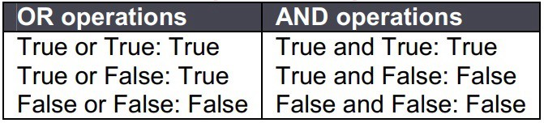
11. What are function in python?
A function is a block of organized, reusable code that is used to perform a single, related action.
def round_to_two_places(num):
return round(num, 2)
pi = round_to_two_places(3.14159)
The output is 3.14
12. Calculating remainder in python?
91 % 3
The output is 1
13. Who created python?

Python is an interpreted, high-level, general-purpose programming language.
Python was created by Guido van Rossum
14. When was python created?

Python was conceived in the late 1980s as a successor to the ABC language
The first version was releases in 1991
Python 2.0 was released in 2000
Python 3.0 was released in 2008
15. What are the built-in type does python provides?
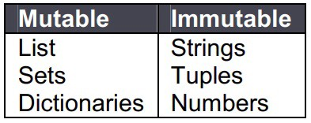
16. What is lambda in Python?

It is a single expression anonymous function used as inline function.
x = lambda a : a + 10
x(5)
The output is 15
17. What is pass in Python?

Pass means, no-operation Python statement.
It is a place holder in compound statement, where nothing has to be written.
18. What is slicing?

A mechanism to select a range of items from sequence types like list, tuple, strings etc. is known as slicing.
x[1, 2, 3, 4, 5]
x[0:2] → [1,2]
x[2:] → [3,4,5]
19. What is negative index in Python?

Python sequences can be index in positive and negative numbers.
For positive index, 0 is the first index, 1 is the second index and so forth.
For negative index, (-1) is the last index and (-2) is the second last index and so forth.

20. How you can convert a number to a string?

In order to convert a number into a string, use the inbuilt function str().
If you want a octal or hexadecimal representation, use the inbuilt function oct() or hex().
21. What is range function?

The range() function returns a sequence of numbers, starting from 0 by default, and increments by 1 (by default), and stops before a specified number.
x = range(6)
for n in x:
print(n)
The output is 0, 1, 2, 3, 4, 5
22. How do you generate random numbers in Python?

Library: import random
Syntax: random.random()
Output: Returns a random floating point number in the range [0,1)
23. What is the difference between / and // operator in Python?
// is a Floor Division operator
It is used for dividing two operands with the result as quotient showing only digits before the decimal point.
10 / 3 = 3.33333
10 // 3 = 3
24. What is the use of the split function in Python?

The use of the split function in Python is that it breaks a string into shorter strings using the defined separator.
It gives a list of all words present in the string.
25. What is the difference between a list and a tuple?

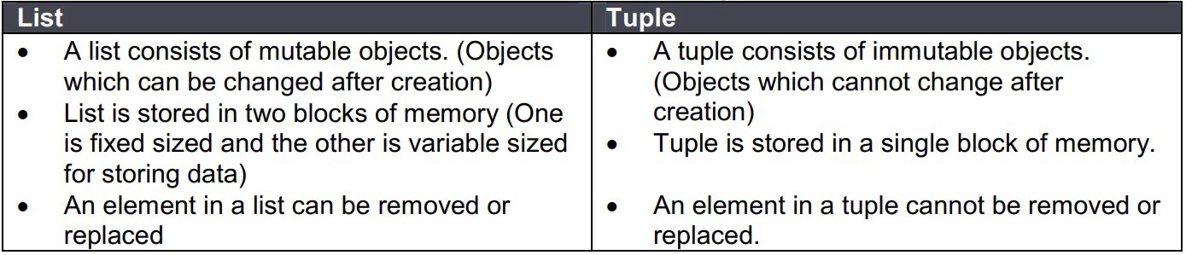

26. What is the difference between an array and a list?
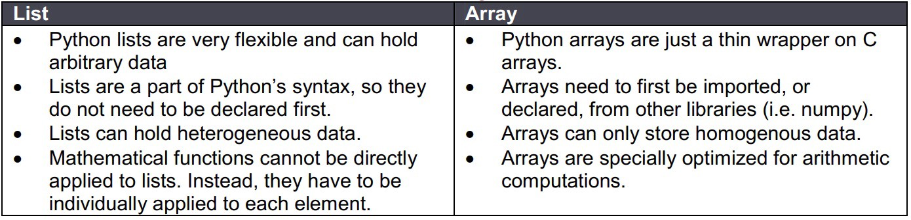
27. How would you convert a list to an array?

This is done using numpy.array().
This function of the numpy library takes a list as an argument and returns an array that contains all the elements of the list.
28. What are the advantages of NumPy arrays over Python lists?

NumPy is more convenient.
You get a lot of vector and matrix operations, which sometimes allow one to avoid unnecessary work.
You get a lot built in functions with NumPy for fast searching, basic statistics, linear algebra, histograms, etc.
29. What are global and local variables in Python?

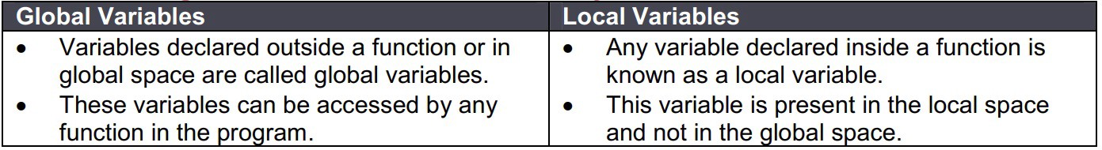
30. Explain the differences between Python 2 and Python 3?

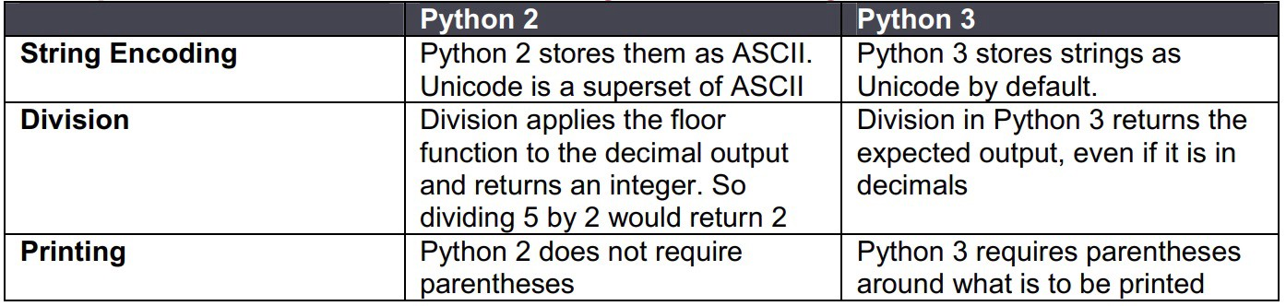
31. What is dictionary comprehension in Python?

Dictionary comprehension is one way to create a dictionary in Python.
It creates a dictionary by merging two sets of data which are in the form of either lists or arrays.
rollNumbers =[122, 233, 353, 456]
names = [‘alex’, ‘bob’, ‘can’, ‘don’]
NewDictionary={ i:j for (i,j) in zip (rollNumbers,names)}
The output is {(122, ‘alex’), (233, ‘bob’), (353, ‘can’), (456, ‘don’)
32. How would you sort a dictionary in Python?

Dictionary.keys() : Returns only the keys in an arbitrary order.
Dictionary.values() : Returns a list of values.
Dictionary.items() : Returns all of the data as a list of key-value pairs.
Sorted(): This method takes one mandatory and two optional arguments
33. How do you reverse a string in Python?

Stringname = ‘python’
Stringname[::-1]
The output is ‘nohtyp’
34. How do you check if a Python string contains another string?

“Python Programming” contains “Programming”
The output is True
“Python Programming” contains “Language”
The output is False

Pandas — 18 questions

35. How to create dataframe from list?

fruit_sales = pd.DataFrame([[35, 21], [41, 34]], columns=[‘Apples’, ‘Bananas’],index=[‘2017 Sales’, ‘2018 Sales’])
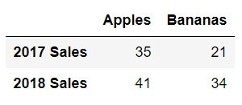
36. How to create dataframe from dictionary?
animals = pd.DataFrame({‘Cows’: [12, 20], ‘Goats’: [22, 19]}, index=[‘Year 1’, ‘Year 2’])
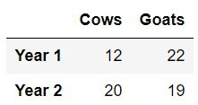
37. How to import csv?
import pandas as pd
cr_data = pd.read_csv(“credit_risk_dataset.csv”)

38. How to export csv?
import pandas as pd
animals.to_csv(“cows_and_goats.csv”)

39. How do you select columns from dataframe?
Selecting the ‘description’ column from ‘reviews’ dataframe
reviews[‘description’]

40. How do you select rows from dataframe?
Selecting the first row from ‘reviews’ dataframe
reviews.iloc[0]
41. How do you select both rows and columns from dataframe?

Selecting the first row of ‘description’ column from ‘reviews’ dataframe
reviews[‘description’].iloc[0]
42. How do you select rows based on indices?

Selecting rows 1, 2, 3, 5 and 8 from ‘reviews’ dataframe
indices = [1, 2, 3, 5, 8]
sample_reviews = reviews.loc[indices]
43. How do you find the median value?

Finding the median of ‘points’ column from ‘reviews’ dataframe
reviews[‘points’].median()
44. How do you find the unique values?

Finding all the unique countries in ‘country’ column from ‘reviews’ dataframe
reviews[‘country’].unique()
45. How do you find count of unique values?

Finding the count of unique countries in ‘country’ column from ‘reviews’ dataframe
reviews[‘country’].value_counts()
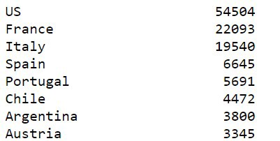
46. How do you group on a particular variable?

Find the count of ‘taster_twitter_handle’ column from ‘reviews’ dataframe
reviews.groupby(‘taster_twitter_handle’).size()
47. How do you apply functions after grouping on a particular variable?

Find the min and max of ‘price’ for different ‘variety’ column from ‘reviews’ dataframe
reviews.groupby(‘variety’).[‘price’].agg([min, max])
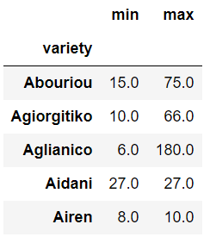
48. How to get the data type of a particular variable?

Get the data type of ‘points’ column from ‘reviews’ dataframe
reviews[‘points’].dtype
49. How do you drop columns?

Dropping columns ‘points’ and ‘country’ from ‘reviews’ dataframe
reviews.drop([‘points’, ‘country’], axis=1, inplace=True)
50. How do you keep columns?

Keeping columns ‘points’ and ‘country’ from ‘reviews’ dataframe
reviews = reviews[[‘points’, ‘country’]]

51. How do you rename a column?

Rename ‘region_1’ as ‘region’ and ‘region_2’ as ‘locale’
reviews.rename(columns=dict(region_1=’region’, region_2=’locale’))
52. How do you sort a dataframe based on a variable?

Sorting ‘region_1’ in descending order
reviews[‘region_1’].sort_values(ascending=False)
Visualization — 8 questions
53. How do you plot a line chart?

import seaborn as sns
sns.lineplot(data=loan_amnt)
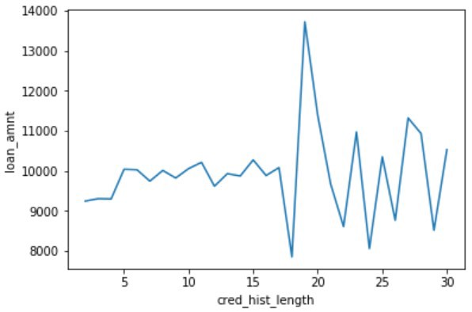
54. How do you plot a bar chart?

import seaborn as sns
sns.barplot(x=cr_data[‘cb_person_default_on_file’], y=cr_data[‘loan_int_rate’])
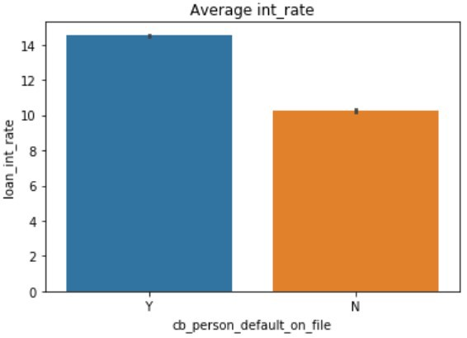
55. How do you plot heat map?

import seaborn as sns
sns.heatmap(num_data.corr(), annot=True)
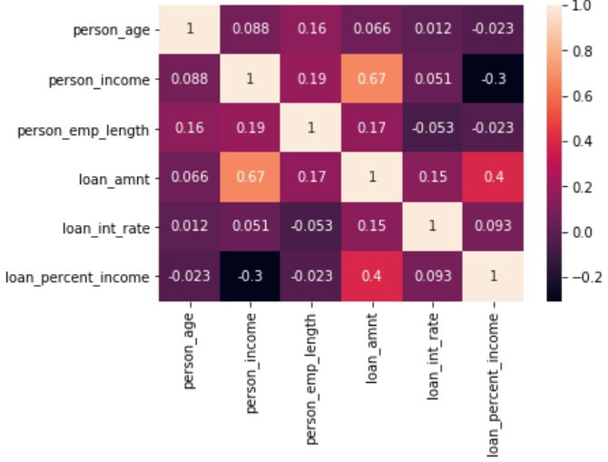
56. How do you plot scatter plot?
import seaborn as sns
sns.scatterplot(x=cr_data[‘loan_amnt’], y=cr_data[‘person_income’])
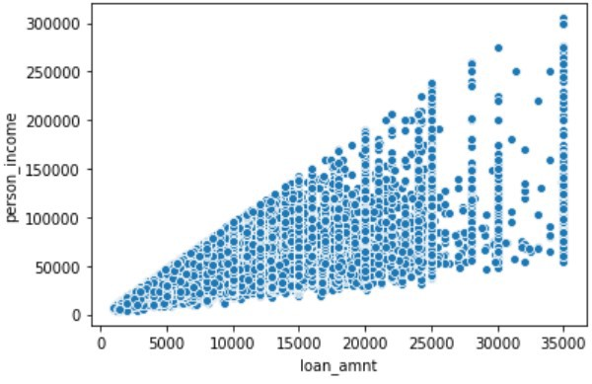
57. How do you plot distribution chart?
import seaborn as sns
sns.distplot(a=cr_data[‘person_income’], label=”person_income”, kde=False)
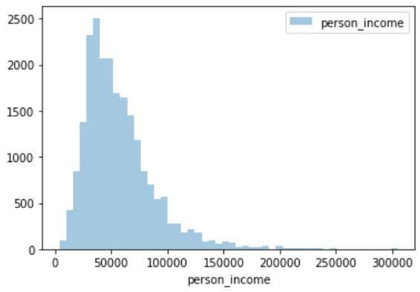
58. How do you add x-label and y-label to the chart?

import matplotlib.pyplot as plt
plt.xlabel(“cred_hist_length”)
plt.ylabel(“loan_amnt”)
59. How do you add title to the chart?

import matplotlib.pyplot as plt
plt.title(“Average int_rate”)
60. How do you add legend to chart?

import matplotlib.pyplot as plt
plt.legend()

Data Cleaning — 5 questions

61. How do you identify missing values?
The function used to identify the missing value is through .isnull()
The code below gives the total number of missing data points in the data frame
missing_values_count = sf_permits.isnull().sum()

62. How do you impute missing values value imputation?
Replace missing values with zero / mean
df[‘income’].fillna(0)
df[‘income’] = df[‘income’].fillna((df[‘income’].mean()))

63. What is scaling of data?
Scaling convert the data using the formula = (value — min value) / (max value — min value)
from sklearn.preprocessing import MinMaxScaler
scaler = MinMaxScaler()
original_data = pd.DataFrame(kickstarters_2017[‘usd_goal_real’])
scaled_data = pd.DataFrame(scaler.fit_transform(original_data))

Original data
Minimum value: 0.01
Maximum value: 166361390.71
Scaled data
Minimum value: 0.0
Maximum value: 1.0

64. What is normalizing of data?
Scaling convert the data using the formula = (value — mean) / standard deviation

from sklearn.preprocessing import StandardScaler
scaler = StandardScaler()
original_data = pd.DataFrame(kickstarters_2017[‘usd_goal_real’])
scaled_data = pd.DataFrame(scaler.fit_transform(original_data))

Original data
Minimum value: 0.01
Maximum value: 166361390.71
Scaled data
Minimum value: -0.10
Maximum value: 212.57

65. How do you treat dates in python?

To convert dates from String to Date
import datetime
import pandas as pd
df[‘Date_parsed’] = pd.to_datetime(df[‘Date’], format=”%m/%d/%Y”)

Machine Learning — 15 questions

66. What is logistic regression?

Logistic regression is a machine learning algorithm for classification. In this algorithm, the probabilities describing the possible outcomes of a single trial are modelled using a logistic function.

67. What is the syntax for logistic regression?

Library: sklearn.linear_model.LogisticRegression
Define model: lr = LogisticRegression()
Fit model: model = lr.fit(x, y)
Predictions: pred = model.predict_proba(test)

68. How do you split the data in train / test?

Library: sklearn.model_selection.train_test_split
Syntax: X_train, X_test, y_train, y_test = train_test_split(X, y, test_size=0.33, random_state=42)

69. What is decision tree?

Given a data of attributes together with its classes, a decision tree produces a sequence of rules that can be used to classify the data.

70. What is the syntax for decision tree classifier?

Library: sklearn.tree.DecisionTreeClassifier
Define model: dtc = DecisionTreeClassifier()
Fit model: model = dtc.fit(x, y)
Predictions: pred = model.predict_proba(test)

71. What is random forest?

Random forest classifier is a meta-estimator that fits a number of decision trees on various sub-samples of datasets and uses average to improve the predictive accuracy of the model and controls over-fitting. The sub-sample size is always the same as the original input sample size but the samples are drawn with replacement.

72. What is the syntax for random forest classifier?

Library: sklearn.ensemble.RandomForestClassifier
Define model: rfc = RandomForestClassifier()
Fit model: model = rfc.fit(x, y)
Predictions: pred = model.predict_proba(test)
73. What is gradient boosting?

Gradient boosting is a machine learning technique for regression and classification problems, which produces a prediction model in the form of an ensemble of weak prediction models, typically decision trees. It builds the model in a stage-wise fashion like other boosting methods do, and it generalizes them by allowing optimization of an arbitrary differentiable loss function.
74. What is the syntax for gradient boosting classifier?

Library: sklearn.ensemble.GradientBoostingClassifier
Define model: gbc = GradientBoostingClassifier()
Fit model: model = gbc.fit(x, y)
Predictions: pred = model.predict_proba(test)
75. What is SVM?

Support vector machine is a representation of the training data as points in space separated into categories by a clear gap that is as wide as possible. New examples are then mapped into that same space and predicted to belong to a category based on which side of the gap they fall.
76. What is the difference between KNN and KMeans?

KNN:
Supervised classification algorithm
Classifies new data points accordingly to the k number or the closest data points
KMeans:
Unsupervised clustering algorithm
Groups data into k number of clusters.
77. How do you treat categorical variables?
Replace categorical variables with the average of target for each category
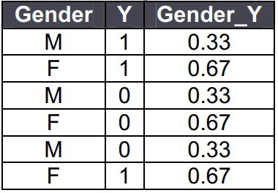
One hot encoding
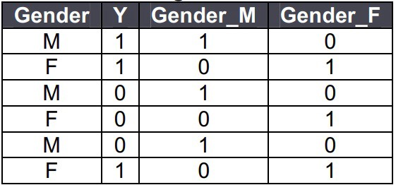

78. How do you treat missing values?

Drop rows having missing values
DataFrame.dropna(axis=0, how=’any’, inplace=True)
Drop columns
DataFrame.dropna(axis=1, how=’any’, inplace=True)
Replace missing values with zero / mean

df[‘income’].fillna(0)
df[‘income’] = df[‘income’].fillna((df[‘income’].mean()))
79. How do you treat outliers?

Inter quartile range is used to identify the outliers.
Q1 = df[‘income’].quantile(0.25)
Q3 = df[‘income’].quantile(0.75)
IQR = Q3 — Q1
df = df[(df[‘income’] >= (Q1–1.5 * IQR)) & (df[‘income’] <= (Q3 + 1.5 * IQR))]
80. What is bias / variance trade off?
Definition
The Bias-Variance Trade off is relevant for supervised machine learning, specifically for predictive modelling. It’s a way to diagnose the performance of an algorithm by breaking down its prediction error.
Error from Bias
Bias is the difference between your model’s expected predictions and the true values.
This is known as under-fitting.
Does not improve with collecting more data points.
Error from Variance
Variance refers to your algorithm’s sensitivity to specific sets of training data.
This is known as over-fitting.
Improves with collecting more data points.

Data Science Python Interview Questions and Answers
Source: https://www.dezyre.com/article/100-data-science-in-python-interview-questions-and-answers-for-2021/188
The questions below are based on the course that is taught at ProjectPro – Data Science in Python. This is not a guarantee that these questions will be asked in Data Science Interviews. The purpose of these questions is to make the reader aware of the kind of knowledge that an applicant for a Data Scientist position needs to possess.
Data Science Interview Questions in Python are generally scenario based or problem based questions where candidates are provided with a data set and asked to do data munging, data exploration, data visualization, modelling, machine learning, etc. Most of the data science interview questions are subjective and the answers to these questions vary, based on the given data problem. The main aim of the interviewer is to see how you code, what are the visualizations you can draw from the data, the conclusions you can make from the data set, etc.
- How can you build a simple logistic regression model in Python?
- 2) How can you train and interpret a linear regression model in SciKit learn?
3) Name a few libraries in Python used for Data Analysis and Scientific computations.
NumPy, SciPy, Pandas, SciKit, Matplotlib, Seaborn
4) Which library would you prefer for plotting in Python language: Seaborn or Matplotlib?
Matplotlib is the python library used for plotting but it needs lot of fine-tuning to ensure that the plots look shiny. Seaborn helps data scientists create statistically and aesthetically appealing meaningful plots. The answer to this question varies based on the requirements for plotting data.
5) What is the main difference between a Pandas series and a single-column DataFrame in Python?
6) Write code to sort a DataFrame in Python in descending order.
7) How can you handle duplicate values in a dataset for a variable in Python? (get solved use-cases + code)
8) Which Random Forest parameters can be tuned to enhance the predictive power of the model?
9) Which method in pandas.tools.plotting is used to create scatter plot matrix?
Scatter_matrix
10) How can you check if a data set or time series is Random?
To check whether a dataset is random or not use the lag plot. If the lag plot for the given dataset does not show any structure then it is random.
11) Can we create a DataFrame with multiple data types in Python? If yes, how can you do it?
12) Is it possible to plot histogram in Pandas without calling Matplotlib? If yes, then write the code to plot the histogram?
13) What are the possible ways to load an array from a text data file in Python? How can the efficiency of the code to load data file be improved?
numpy.loadtxt ()
14) Which is the standard data missing marker used in Pandas?
NaN
15) Why you should use NumPy arrays instead of nested Python lists?
Recommended Reading: Deep Learning Interview Questions and Answers
16) What is the preferred method to check for an empty array in NumPy? (get solved use-cases + code)
17) List down some evaluation metrics for regression problems.
18) Which Python library would you prefer to use for Data Munging?
Pandas
19) Write the code to sort an array in NumPy by the nth column?
Using argsort () function this can be achieved. If there is an array X and you would like to sort the nth column then code for this will be x[x [: n-1].argsort ()]
20) How are NumPy and SciPy related?
21) Which python library is built on top of matplotlib and Pandas to ease data plotting?
Seaborn
22) Which plot will you use to access the uncertainty of a statistic?
Bootstrap
23) What are some features of Pandas that you like or dislike?
24) Which scientific libraries in SciPy have you worked with in your project?
25) What is pylab?
A package that combines NumPy, SciPy and Matplotlib into a single namespace.
26) Which python library is used for Machine Learning?
SciKit-Learn

Basic Python Programming Interview Questions
27) How can you copy objects in Python?
The functions used to copy objects in Python are-
1) Copy.copy () for shallow copy
2) Copy.deepcopy () for deep copy
However, it is not possible to copy all objects in Python using these functions. For instance, dictionaries have a separate copy method whereas sequences in Python have to be copied by ‘Slicing’.
28) What is the difference between tuples and lists in Python?
Tuples can be used as keys for dictionaries i.e. they can be hashed. Lists are mutable whereas tuples are immutable - they cannot be changed. Tuples should be used when the order of elements in a sequence matters. For example, set of actions that need to be executed in sequence, geographic locations or list of points on a specific route.
29) What is PEP8?
PEP8 consists of coding guidelines for Python language so that programmers can write readable code making it easy to use for any other person, later on.
30) Is all the memory freed when Python exits?
No it is not, because the objects that are referenced from global namespaces of Python modules are not always de-allocated when Python exits.
31) What does _init_.py do?
_init_.py is an empty py file used for importing a module in a directory. _init_.py provides an easy way to organize the files. If there is a module maindir/subdir/module.py,_init_.py is placed in all the directories so that the module can be imported using the following command-
import maindir.subdir.module
32) What is the different between range () and xrange () functions in Python?
range () returns a list whereas xrange () returns an object that acts like an iterator for generating numbers on demand.
33) How can you randomize the items of a list in place in Python? (get solved use-cases + code)
Shuffle (lst) can be used for randomizing the items of a list in Python
34) What is a pass in Python?
Pass in Python signifies a no operation statement indicating that nothing is to be done.
35) If you are gives the first and last names of employees, which data type in Python will you use to store them?
You can use a list that has first name and last name included in an element or use Dictionary.
36) What happens when you execute the statement mango=banana in Python?
A name error will occur when this statement is executed in Python.
37) Write a sorting algorithm for a numerical dataset in Python. (get solved use-cases + code)
38) Optimize the below python code-
word = 'word'
print word.__len__ ()
Answer: print ‘word’._len_ ()
39) What is monkey patching in Python?
Monkey patching is a technique that helps the programmer to modify or extend other code at runtime. Monkey patching comes handy in testing but it is not a good practice to use it in production environment as debugging the code could become difficult.
40) Which tool in Python will you use to find bugs if any?
Pylint and Pychecker. Pylint verifies that a module satisfies all the coding standards or not. Pychecker is a static analysis tool that helps find out bugs in the course code.
41) How are arguments passed in Python- by reference or by value?
The answer to this question is neither of these because passing semantics in Python are completely different. In all cases, Python passes arguments by value where all values are references to objects.
42) You are given a list of N numbers. Create a single list comprehension in Python to create a new list that contains only those values which have even numbers from elements of the list at even indices. For instance if list[4] has an even value the it has be included in the new output list because it has an even index but if list[5] has an even value it should not be included in the list because it is not at an even index.
[x for x in list [1::2] if x%2 == 0]
The above code will take all the numbers present at even indices and then discard the odd numbers.
43) Explain the usage of decorators.
Decorators in Python are used to modify or inject code in functions or classes. Using decorators, you can wrap a class or function method call so that a piece of code can be executed before or after the execution of the original code. Decorators can be used to check for permissions, modify or track the arguments passed to a method, logging the calls to a specific method, etc.
44) How can you check whether a pandas data frame is empty or not? (get solved use-cases + code)
The attribute df.empty is used to check whether a data frame is empty or not.
45) What will be the output of the below Python code –
def multipliers ():
return [lambda x: i * x for i in range (4)]
print [m (2) for m in multipliers ()]
The output for the above code will be [6, 6,6,6]. The reason for this is that because of late binding the value of the variable i is looked up when any of the functions returned by multipliers are called.
46) What do you mean by list comprehension?
The process of creating a list while performing some operation on the data so that it can be accessed using an iterator is referred to as List Comprehension.
Example:
[ord (j) for j in string.ascii_uppercase]
[65, 66, 67, 68, 69, 70, 71, 72, 73, 74, 75, 76, 77, 78, 79, 80, 81, 82, 83, 84, 85, 86, 87, 88, 89, 90]
Matser Data Science with Python by working on innovative Data Science Projects in Python
47) What will be the output of the below code
word = ‘aeioubcdfg'
print word [:3] + word [3:]
The output for the above code will be: ‘aeioubcdfg'.
In string slicing when the indices of both the slices collide and a “+” operator is applied on the string it concatenates them.
48) list= [‘a’,’e’,’i’,’o’,’u’]
print list [8:]
The output for the above code will be an empty list []. Most of the people might confuse the answer with an index error because the code is attempting to access a member in the list whose index exceeds the total number of members in the list. The reason being the code is trying to access the slice of a list at a starting index which is greater than the number of members in the list.
49) What will be the output of the below code: (get solved use-cases + code)
def foo (i= []):
i.append (1)
return i
>>> foo ()
>>> foo ()
The output for the above code will be-
[1]
[1, 1]
The argument to the function foo is evaluated only once when the function is defined. However, since it is a list, on every all the list is modified by appending a 1 to it.
50) Can the lambda forms in Python contain statements?
No, as their syntax is restricted to single expressions and they are used for creating function objects which are returned at runtime.
This list of questions for Python interview questions and answers is not an exhaustive one and will continue to be a work in progress. Let us know in the comments below if we missed out on any important question that needs to be up here.

Facebook Data Science Interview Questions
1) A building has 100 floors. Given 2 identical eggs, how can you use them to find the threshold floor? The egg will break from any particular floor above floor N, including floor N itself.
2) In a given day, how many birthday posts occur on Facebook?
3) You are at a Casino. You have two dices to play with. You win $10 every time you roll a 5. If you play till you win and then stop, what is the expected pay-out?
4) How many big Macs does McDonald sell every year in US?
5) You are about to get on a plane to Seattle, you want to know whether you have to bring an umbrella or not. You call three of your random friends and as each one of them if it’s raining. The probability that your friend is telling the truth is 2/3 and the probability that they are playing a prank on you by lying is 1/3. If all 3 of them tell that it is raining, then what is the probability that it is actually raining in Seattle.
6) You can roll a dice three times. You will be given $X where X is the highest roll you get. You can choose to stop rolling at any time (example, if you roll a 6 on the first roll, you can stop). What is your expected pay-out?
7) How can bogus Facebook accounts be detected?
8) You have been given the data on Facebook user’s friending or defriending each other. How will you determine whether a given pair of Facebook users are friends or not?
9) How many dentists are there in US?
10) You have 2 dices. What is the probability of getting at least one 4? Also find out the probability of getting at least one 4 if you have n dices.
11) Pick up a coin C1 given C1+C2 with probability of trials p (h1) =.7, p (h2) =.6 and doing 10 trials. And what is the probability that the given coin you picked is C1 given you have 7 heads and 3 tails?
12) You are given two tables- friend_request and request_accepted. Friend_request contains requester_id, time and sent_to_id and request_accepted table contains time, acceptor_id and requestor_id. How will you determine the overall acceptance rate of requests?
13) How would add new Facebook members to the database of members, and code their relationships to others in the database? (click here to get solved use-cases + code)
14) What would you add to Facebook and how would you pitch it and measure its success?
15) How will you test that there is increased probability of a user to stay active after 6 months given that a user has more friends now?
16) You have two tables-the first table has data about the users and their friends, the second table has data about the users and the pages they have liked. Write an SQL query to make recommendations using pages that your friends liked. The query result should not recommend the pages that have already been liked by a user.
17) What is the probability of pulling a different shape or a different colour card from a deck of 52 cards?
18) Which technique will you use to compare the performance of two back-end engines that generate automatic friend recommendations on Facebook?
19) Implement a sorting algorithm for a numerical dataset in Python.
20) How many people are using Facebook in California at 1.30 PM on Monday?
21) You are given 50 cards with five different colors- 10 Green cards, 10 Red Cards, 10 Orange Cards, 10 Blue cards, and 10 Yellow cards. The cards of each colors are numbered from one to ten. Two cards are picked at random. Find out the probability that the cards picked are not of same number and same color.

Insight Data Science Interview Questions
1) Which companies participating in Insight would you be interested in working for?
2) Create a program in a language of your choice to read a text file with various tweets. The output should be 2 text files-one that contains the list of all unique words among all tweets along with the count for repeated words and the second file should contain the medium number of unique words for all tweets.
3) What motivates you to transition from academia to data science?

Twitter Data Scientist Interview Questions
1) How can you measure engagement with given Twitter data?
2) Give a large dataset, find the median.
3) What is the good measure of influence of a Twitter user?

AirBnB Data Science Interview Questions
1) Do you have some knowledge of R - analyse a given dataset in R?
2) What will you do if removing missing values from a dataset cause bias?
3) How can you reduce bias in a given data set?
4) How will you impute missing information in a dataset?

Google Data Science Interview Questions (click here to get solved use-cases + code)
1) Explain about string parsing in R language
2) A disc is spinning on a spindle and you don’t know the direction in which way the disc is spinning. You are provided with a set of pins.How will you use the pins to describe in which way the disc is spinning?
3) Describe the data analysis process.
4) How will you cut a circular cake into 8 equal pieces?

LinkedIn Data Science Interview Questions
1) Find out K most frequent numbers from a given stream of numbers on the fly.
2) Given 2 vectors, how will you generate a sorted vector?
3) Implementing pow function
4) What kind of product you want to build at LinkedIn?
5) How will you design a recommendation engine for jobs?
6) Write a program to segment a long string into a group of valid words using Dictionary. The result should return false if the string cannot be segmented. Also explain about the complexity of the devised solution.
7) Define an algorithm to discover when a person is starting to search for new job.
8) What are the factors used to produce “People You May Know” data product on LinkedIn?
9) How will you find the second largest element in a Binary Search tree ? (Asked for a Data Scientist Intern job role)

Mu Sigma Data Science Interview Questions
1) Explain the difference between Supervised and Unsupervised Learning through examples.
2) How would you add value to the company through your projects?
3) Case Study based questions – Cars are implanted with speed tracker so that the insurance companies can track about our driving state. Based on this new scheme what kind of business questions can be answered?
4) Define standard deviation, mean, mode and median.
5) What is a joke that people say about you and how would you rate the joke on a scale of 1 to 10?
6) You own a clothing enterprise and want to improve your place in the market. How will you do it from the ground level ?
7) How will you customize the menu for Cafe Coffee Day ?

Amazon Data Science Interview Questions
1) Estimate the probability of a disease in a particular city given that the probability of the disease on a national level is low.
2) How will inspect missing data and when are they important for your analysis?
3) How will you decide whether a customer will buy a product today or not given the income of the customer, location where the customer lives, profession and gender? Define a machine learning algorithm for this.
4) From a long sorted list and a short 4 element sorted list, which algorithm will you use to search the long sorted list for 4 elements.
5) How can you compare a neural network that has one layer, one input and output to a logistic regression model?
6) How do you treat colinearity?
7) How will you deal with unbalanced data where the ratio of negative and positive is huge?
8) What is the difference between -
i) Stack and Queue
ii) Linkedin and Array

Uber Data Science Interview Questions (click here to get solved use-cases + code)
1) Will Uber cause city congestion?
2) What are the metrics you will use to track if Uber’s paid advertising strategies to acquire customers work? How will you figure out the acceptable cost of customer acquisition?
3) Explain principal components analysis with equations.
4) Explain about the various time series forecasting technqiues.
5) Which machine learning algorithm will you use to solve a Uber driver accepting request?
6)How will you compare the results of various machine learning algorithms?
7) How to solve multi-collinearity?
8) How will you design the heatmap for Uber drivers to provide recommendation on where to wait for passengers? How would you approach this?
9) If we added one rider to the current SF market, how would that affect the existing riders and drivers?
10) What are the different performance metrics for evaluating Uber services?
11) How will you decide which version (Version 1 or Version 2) of the Surge Pricing Algorithms is working better for Uber ?
12) How will you explain JOIN function in SQL to a 10 year old ?

Netflix Data Science Interview Questions
1) How can you build and test a metric to compare ranked list of TV shows or Movies for two Netflix users?
2) How can you decide if one algorithm is better than the other?

Microsoft Data Science Interview Questions
1) Write a function to check whether a particular word is a palindrome or not.
2) How can you compute an inverse matrix faster by playing with some computation tricks?
3) You have a bag with 6 marbles. One marble is white. You reach the bag 100 times. After taking out a marble, it is placed back in the bag. What is the probability of drawing a white marble at least once?

Apple Data Science Interview Questions
1) How do you take millions of users with 100's of transactions each, amongst 10000's of products and group the users together in a meaningful segments?

Adobe Data Scientist Interview Questions
1) Check whether a given integer is a palindrome or not without converting it to a string.
2) What is the degree of freedom for lasso?
3) You have two sorted array of integers, write a program to find a number from each array such that the sum of the two numbers is closest to an integer i.

American Express Data Scientist Interview Questions
1) Suppose that American Express has 1 million card members along with their transaction details. They also have 10,000 restaurants and 1000 food coupons. Suggest a method which can be used to pass the food coupons to users given that some users have already received the food coupons so far.
2) You are given a training dataset of users that contain their demographic details, the pages on Facebook they have liked so far and results of psychology test based on their personality i.e. their openness to like FB pages or not. How will you predict the age, gender and other demographics of unseen data?

Quora Data Scientist Interview Questions
1) How will you test a machine learning model for accuracy?
2) Print the elements of a matrix in zig-zag manner.
3) How will you overcome overfitting in predictive models?
4) Develop an algorithm to sort two lists of sorted integers into a single list.

Goldman Sachs Data Scientist Interview Questions
1) Count the total number of trees in United States.
2) Estimate the number of square feet pizza’s eaten in US each year.
3) A box has 12 red cards and 12 black cards. Another box has 24 red cards and 24 black cards. You want to draw two cards at random from one of the two boxes, which box has a higher probability of getting cards of same colour and why?
4) How will you prove that the square root of 2 is irrational?
5) What is the probability of getting a HTT combination before getting a TTH combination?
6) There are 8 identical balls and only one of the ball is slightly heavier than the others. You are given a balance scale to find the heavier ball. What is the least number of times you have to use the balance scale to find the heavier ball?

Walmart Data Science Interview Questions
1) Write the code to reverse a Linked list.
2) What assumptions does linear regression machine learning algorithm make?
3) A stranger uses a search engine to find something and you do not know anything about the person. How will you design an algorithm to determine what the stranger is looking for just after he/she types few characters in the search box?
4) How will you fix multi-colinearity in a regression model?
5) What data structures are available in the Pandas package in Python programming language?
6) State some use cases where Hadoop MapReduce works well and where it does not.
7) What is the difference between an iterator, generator and list comprehension in Python?
8) What is the difference between a bagged model and a boosted model?
9) What do you understand by parametric and non-parametric methods? Explain with examples.
10) Have you used sampling? What are the various types of sampling have you worked with?
11) Explain about cross entropy ?
12) What are the assuptions you make for linear regression ?
13) Differentiate between gradient boosting and random forest.
14) What is the signigicance of log odds ?

IBM Data Science Interview Questions
1) How will you handle missing data ?

Yammer Data Science Interview Questions
- How can you solve a problem that has no solution?
- On rolling a dice if you get $1 per dot on the upturned face,what are your expected earnings from rolling a dice?
- In continuation with question #2, if you have 2 chances to roll the dice and you are given the opportunity to decide when to stop rolling the dice (in the first roll or in the second roll). What will be your rolling strategy to get maximum earnings?
- What will be your expected earnings with the two roll strategy?
- You are creating a report for user content uploads every month and observe a sudden increase in the number of upload for the month of November. The increase in uploads is particularly in image uploads. What do you think will be the cause for this and how will you test this sudden spike?

Citi Bank Data Science Interview Questions
1) A dice is rolled twice, what is the probability that on the second chance it will be a 6?
2) What are Type 1 and Type 2 errors ?
3) Burn two ropes, one needs 60 minutes of time to burn and the other needs 30 minutes of time. How will you achieve this in 45 minutes of time ?

Data Science Interview Questions Asked at Other Top Tech Companies
1) R programming language cannot handle large amounts of data. What are the other ways of handling it without using Hadoop infrastructure? (Asked at Pyro Networks)
2) Explain the working of a Random Forest Machine Learning Algorithm (Asked at Cyient)
3) Describe K-Means Clustering.(Asked at Symphony Teleca)
4) What is the difference between logistic and linear regression? (Asked at Symphony Teleca)
5) What kind of distribution does logistic regression follow? (Asked at Symphony Teleca)
6) How do you parallelize machine learning algorithms? (Asked at Vodafone) (get interview problems + solution code)
7) When required data is not available for analysis, how do you go about collecting it? (Asked at Vodafone)
8) What do you understand by heteroscadisticity (Asked at Vodafone)
9) What do you understand by confidence interval? (Asked at Vodafone)
10) Difference between adjusted r and r square. (Asked at Vodafone)
11) How Facebook recommends items to newsfeed? (Asked at Finomena)
12) What do you understand by ROC curve and how is it used? (Asked at MachinePulse)
13) How will you identify the top K queries from a file? (Asked at BloomReach)
14) Given a set of webpages and changes on the website, how will you test the new website feature to determine if the change works positively? (Asked at BloomReach)
15) There are N pieces of rope in a bucket. You put your hand into the bucket, take one end piece of the rope .Again you put your hand into the bucket and take another end piece of a rope. You tie both the end pieces together. What is the expected value of the number of loops within the bucket? (Asked at Natera)
16) How will you test if a chosen credit scoring model works or not? What data will you look at? (Asked at Square)
17) There are 10 bottles where each contains coins of 1 gram each. There is one bottle of that contains 1.1 gram coins. How will you identify that bottle after only one measurement? (Data Science Puzzle asked at Latent View Analytics)
18) How will you measure a cylindrical glass filled with water whether it is exactly half filled or not? You cannot measure the water, you cannot measure the height of the glass nor can you dip anything into the glass. (Data Science Puzzle asked at Latent View Analytics)
19) What would you do if you were a traffic sign? (Data Science Interview Question asked at Latent View Analytics)
20) If you could get the dataset on any topic of interest, irespective of the collection methods or resources then how would the dataset look like and what will you do with it. (Data Scientist Interview Question asked at CKM Advisors)
21) Given n samples from a uniform distribution [0,d], how will you estimate the value of d? (Data Scientist Interview Question asked at Spotify)
22) How will you tune a Random Forest? (Data Science Interview Question asked at Instacart). (get interview problems + solution code)
23) Tell us about a project where you have extracted useful information from a large dataset. Which machine learning algorithm did you use for this and why? (Data Scientist Interview Question asked at Greenplum)
24) What is the difference between Z test and T test ? (Data Scientist Interview Questions asked at Antuit)
25) What are the different models you have used for analysis and what were your inferences? (Data Scientist Interview Questions asked at Cognizant)
26) Given the title of a product, identify the category and sub-category of the product. (Data Scientist interview question asked at Delhivery)
27) What is the difference between machine learning and deep learning? ( Data Scientist Interview Question asked at InfoObjects)
28) What are the different parameters in ARIMA models ? (Data Science Interview Question asked at Morgan Stanley)
29) What are the optimisations you would consider when computing the similarity matrix for a large dataset? (Data Science Interview questions asked at MakeMyTrip)
30) Use Python programming language to implement a toolbox with specific image processing tasks.(Data Science Interview Question asked at Intuitive Surgical)
31) Why do you use Random Forest instead of a simple classifier for one of the classification problems ? (Data Science Interview Question asked at Audi)
32) What is an n-gram? (Data Science Interview Question asked at Yelp)
33) What are the problems related to Overfitting and Underfitting and how will you deal with these ? (Data Science Interview Question asked at Tiger Analytics)
34) Given a MxN dimension matrix with each cell containing an alphabet, find if a string is contained in it or not.(Data Science Interview Question asked at Tiger Analytics)
35) How do you "Group By" in R programming language without making use of any package ? (Data Scientist Interview Question asked at OLX)
36) List 15 features that you will make use of to build a classifier for OLX website.(Data Scientist Interview Question asked at OLX)
37) How will you build a caching system using an advanced data structure like hashmap ? (Data Scientist Interview Question asked at OLX)
38) How to reverse strings that have changing positions ? (Data Scientist Interview Question asked at Tiger Analytics)
39) How do you select a cricket team ? (Data Scientist Interview Question asked at Quantiphi)
40) What is the difference between trees and random forest ? (Data Scientist Interview Question asked at Salesforce)
If you are asked questions like what is your favourite leisure activity? Or something like what is that you like to do for fun? Most of the people often tend to answer that they like to read programming books or do coding thinking that this is what they are supposed to say in a technical interview. Is this something you really do it for fun? A key point to bear in mind that the interviewer is also a person and interact with them as a person naturally. This will help the interviewer see you as an all-rounder who can visualize the company’s whole vision and not just view business problems from an academic viewpoint.

Top 100 Common Data Scientist Interview Questions and Answers
1)Differentiate between Data Science, Machine Learning, and AI.
Access 100+ ready-to-use, sample Python and R codes for data science to prepare for your Data Science Interview
Data Science vs Machine Learning
Criteria | Data Science | Machine Learning | Artificial Intelligence
Definition | Data Science is not exactly a subset of machine learning but it uses machine learning to analyze and make future predictions. | A subset of AI that focuses on a narrow range of activities. | A wide term that focuses on applications ranging from Robotics to Text Analysis.
Role | It can take on a business role. | It is a purely technical role. | It is a combination of both business and technical aspects.
Scope | Data Science is a broad term for diverse disciplines and is not merely about developing and training models. | Machine learning fits within the data science spectrum. | AI is a sub-field of computer science.
AI | Loosely integrated | Machine learning is a subfield of AI and is tightly integrated. | A sub-field of computer science consisting of various tasks like planning, moving around in the world, recognizing objects and sounds, speaking, translating, performing social or business transactions, creative work.
2) Python or R – Which one would you prefer for text analytics?
The best possible answer for this would be Python because it has a Pandas library that provides easy-to-use data structures and high-performance data analysis tools.
3) Which technique is used to predict categorical responses?
Classification technique is used widely in mining for classifying data sets.
What is logistic regression? Or State an example when you have used logistic regression recently. (Access a sample use-case on Logistic Regression)
Logistic Regression often referred to as the logit model is a technique to predict the binary outcome from a linear combination of predictor variables. For example, if you want to predict whether a particular political leader will win the election or not. In this case, the outcome of prediction is binary i.e. 0 or 1 (Win/Lose). The predictor variables here would be the amount of money spent for election campaigning of a particular candidate, the amount of time spent in campaigning, etc.
5) What are Recommender Systems?
A subclass of information filtering systems that are meant to predict the preferences or ratings that a user would give to a product. Recommender systems are widely used in movies, news, research articles, products, social tags, music, etc.
6) Why data cleaning plays a vital role in the analysis? (Access popular Python and R Codes for data cleaning )
Cleaning data from multiple sources to transform it into a format that data analysts or data scientists can work with is a cumbersome process because - as the number of data sources increases, the time take to clean the data increases exponentially due to the number of sources and the volume of data generated in these sources. It might take up to 80% of the time for just cleaning data making it a critical part of the analysis task.
7) Differentiate between univariate, bivariate, and multivariate analysis.
These are descriptive statistical analysis techniques that can be differentiated based on the number of variables involved at a given point in time. For example, the pie charts of sales based on territory involve only one variable and can be referred to as univariate analysis.
If the analysis attempts to understand the difference between 2 variables at the time as in a scatterplot, then it is referred to as bivariate analysis. For example, analyzing the volume of sales and spending can be considered as an example of bivariate analysis.
Analysis that deals with the study of more than two variables to understand the effect of variables on the responses is referred to as multivariate analysis.
8) What do you understand by the term Normal Distribution? (Learn how to plot normal distribution using Seaborn)
Data is usually distributed in different ways with a bias to the left or to the right or it can all be jumbled up. However, there are chances that data is distributed around a central value without any bias to the left or right and reaches normal distribution in the form of a bell-shaped curve. The random variables are distributed in the form of a symmetrical bell shaped curve.
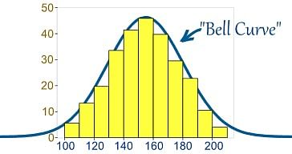
Image Credit: mathisfun.com
9) What is Linear Regression?
Linear regression is a statistical technique where the score of a variable Y is predicted from the score of a second variable X. X is referred to as the predictor variable and Y as the criterion variable.
10) What are Interpolation and Extrapolation?
Estimating a value from 2 known values from a list of values is Interpolation. Extrapolation is approximating a value by extending a known set of values or facts.
11) What is power analysis?
An experimental design technique for determining the effect of a given sample size.
12) What is K-means? How can you select K for K-means?
13) What is Collaborative filtering?
The process of filtering used by most of the recommender systems to find patterns or information by collaborating viewpoints, various data sources, and multiple agents.
14) What is the difference between Cluster and Systematic Sampling?
Cluster sampling is a technique used when it becomes difficult to study the target population spread across a wide area and simple random sampling cannot be applied. A cluster sample is a probability sample where each sampling unit is a collection or cluster of elements. Systematic sampling is a statistical technique where elements are selected from an ordered sampling frame. In systematic sampling, the list is progressed in a circular manner so once you reach the end of the list, it is progressed from the top again. The best example for systematic sampling is the equal probability method.
15) Are expected value and mean value different?
They are not different but the terms are used in different contexts. Mean is generally referred to when talking about a probability distribution or sample population whereas expected value is generally referred in a random variable context.
For Sampling Data
The mean value is the only value that comes from the sampling data.
Expected Value is the mean of all the means i.e. the value that is built from multiple samples. The expected value is the population mean.
For Distributions
Mean value and Expected value are the same irrespective of the distribution, under the condition that the distribution is in the same population.
16) What does P-value signify about the statistical data?
P-value is used to determine the significance of results after a hypothesis test in statistics. P-value helps the readers to draw conclusions and is always between 0 and 1.
• P-Value > 0.05 denotes weak evidence against the null hypothesis which means the null hypothesis cannot be rejected.
• P-value <= 0.05 denotes strong evidence against the null hypothesis which means the null hypothesis can be rejected.
• P-value=0.05is the marginal value indicating it is possible to go either way.
17) Do gradient descent methods always converge to the same point?
No, they do not because in some cases it reaches a local minima or a local optima point. You don’t reach the global optima point. It depends on the data and starting conditions
18) What is the benefit of shuffling a training dataset when using a batch gradient descent algorithm for optimizing a neural network?
19) A test has a true positive rate of 100% and false-positive rate of 5%. There is a population with a 1/1000 rate of having the condition the test identifies. Considering a positive test, what is the probability of having that condition?
Let’s suppose you are being tested for a disease, if you have the illness the test will end up saying you have the illness. However, if you don’t have the illness- 5% of the time the test will end up saying you have the illness, and 95% of the time the test will give an accurate result that you don’t have the illness. Thus there is a 5% error in case you do not have the illness.
Out of 1000 people, 1 person who has the disease will get a true positive result.
Out of the remaining 999 people, 5% will also get true positive results.
Close to 50 people will get a true positive result for the disease.
This means that out of 1000 people, 51 people will be tested positive for the disease even though only one person has the illness. There is only a 2% probability of you having the disease even if your reports say that you have the disease.
20) How you can make data normal using Box-Cox transformation?
21) What is the difference between Supervised Learning and Unsupervised Learning?
If an algorithm learns something from the training data so that the knowledge can be applied to the test data, then it is referred to as Supervised Learning. Classification is an example of Supervised Learning. If the algorithm does not learn anything beforehand because there is no response variable or any training data, then it is referred to as unsupervised learning. Clustering is an example of unsupervised learning.
22) Why it is not advisable to use a softmax output activation function in a multi-label classification problem for a one-hot encoded target?
23) Why is vectorization considered a powerful method for optimizing numerical code?
24) What is the goal of A/B Testing?
It is a statistical hypothesis testing for a randomized experiment with two variables A and B. The goal of A/B Testing is to identify any changes to the web page to maximize or increase the outcome of interest. An example of this could be identifying the click-through rate for a banner ad.
25) What is an Eigenvalue and Eigenvector?
Eigenvectors are used for understanding linear transformations. In data analysis, we usually calculate the eigenvectors for a correlation or covariance matrix. Eigenvectors are the directions along which a particular linear transformation acts by flipping, compressing, or stretching. Eigenvalue can be referred to as the strength of the transformation in the direction of the eigenvector or the factor by which the compression occurs.
26) What is Gradient Descent?
27) Differentiate between a multi-label classification problem and a multi-class classification problem.
28) What is the difference between gradient descent optimization algorithms Adam and Momentum?
29) What are various steps involved in an analytics project?
• Understand the business problem
• Explore the data and become familiar with it.
• Prepare the data for modeling by detecting outliers, treating missing values, transforming variables, etc.
• After data preparation, start running the model, analyze the result and tweak the approach. This is an iterative step till the best possible outcome is achieved.
• Validate the model using a new data set.
• Start implementing the model and track the result to analyse the performance of the model over the period of time.
30) How can you iterate over a list and also retrieve element indices at the same time?
This can be done using the enumerate function which takes every element in a sequence just like in a list and adds its location just before it.
31) During analysis, how do you treat missing values? (get sample code here)
The extent of the missing values is identified after identifying the variables with missing values. If any patterns are identified the analyst has to concentrate on them as it could lead to interesting and meaningful business insights. If there are no patterns identified, then the missing values can be substituted with mean or median values (imputation) or they can simply be ignored.There are various factors to be considered when answering this question-
- Understand the problem statement, understand the data and then give the answer.Assigning a default value which can be mean, minimum or maximum value. Getting into the data is important.
- If it is a categorical variable, the default value is assigned. The missing value is assigned a default value.
- If you have a distribution of data coming, for normal distribution give the mean value.
- Should we even treat missing values is another important point to consider? If 80% of the values for a variable are missing then you can answer that you would be dropping the variable instead of treating the missing values.
32) Explain about the box cox transformation in regression models.
For some reason or the other, the response variable for a regression analysis might not satisfy one or more assumptions of an ordinary least squares regression. The residuals could either curve as the prediction increases or follow skewed distribution. In such scenarios, it is necessary to transform the response variable so that the data meets the required assumptions. A Box cox transformation is a statistical technique to transform non-mornla dependent variables into a normal shape. If the given data is not normal then most of the statistical techniques assume normality. Applying a box cox transformation means that you can run a broader number of tests.
33) Can you use machine learning for time series analysis?
Yes, it can be used but it depends on the applications.
34) Write a function that takes in two sorted lists and outputs a sorted list that is their union.
First solution which will come to your mind is to merge two lists and short them afterwards
What is the difference between Bayesian Estimate and Maximum Likelihood Estimation (MLE)?
In bayesian estimate we have some knowledge about the data/problem (prior) .There may be several values of the parameters which explain data and hence we can look for multiple parameters like 5 gammas and 5 lambdas that do this. As a result of Bayesian Estimate, we get multiple models for making multiple predcitions i.e. one for each pair of parameters but with the same prior. So, if a new example need to be predicted than computing the weighted sum of these predictions serves the purpose.
Maximum likelihood does not take prior into consideration (ignores the prior) so it is like being a Bayesian while using some kind of a flat prior.
36) What is Regularization and what kind of problems does regularization solve?
37) How will you tackle an exploding gradient problem?
38) How will you tackle a vanishing gradient problem?
39) How do you decide whether your linear regression model fits the data?
40) What is the difference between squared error and absolute error?
41) What is Machine Learning?
The simplest way to answer this question is – we give the data and equation to the machine. Ask the machine to look at the data and identify the coefficient values in an equation.
For example for the linear regression y=mx+c, we give the data for the variable x, y and the machine learns about the values of m and c from the data.
Recommended Reading: Deep Learning Interview Questions and Answers
42) How are confidence intervals constructed and how will you interpret them?
43) If the training loss of your model is high and almost equal to the validation loss, what does it mean? What should you do?
44) How can you overcome Overfitting?
45) Differentiate between wide and tall data formats?
46) Is Naïve Bayes bad? If yes, under what aspects.
47) How would you develop a model to identify plagiarism?
48) How will you define the number of clusters in a clustering algorithm?
Though the Clustering Algorithm is not specified, this question will mostly be asked in reference to K-Means clustering where “K” defines the number of clusters. The objective of clustering is to group similar entities in a way that the entities within a group are similar to each other but the groups are different from each other.
For example, the following image shows three different groups.
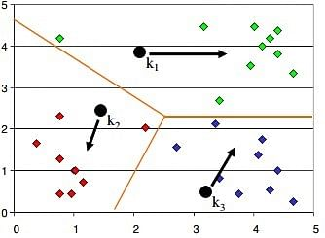
Within Sum of squares is generally used to explain the homogeneity within a cluster. If you plot WSS for a range of number of clusters, you will get the plot shown below. The Graph is generally known as Elbow Curve.
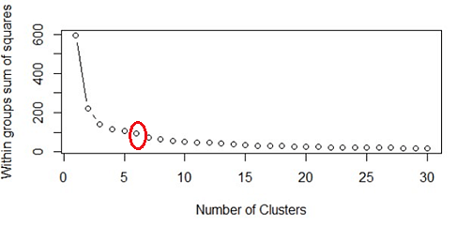
Red circled point in above graph i.e. Number of Cluster =6 is the point after which you don’t see any decrement in WSS. This point is known as bending point and taken as K in K – Means.
This is the widely used approach but few data scientists also use Hierarchical clustering first to create dendograms and identify the distinct groups from there.
49) How important it is to introduce non-linearities in a neural network and why?
50) Is it possible to perform logistic regression with Microsoft Excel?
It is possible to perform logistic regression with Microsoft Excel. There are two ways to do it using Excel.
a) One is to use Add-ins provided by many websites which we can use.
b) Second is to use fundamentals of logistic regression and use Excel’s computational power to build a logistic regression
But when this question is being asked in an interview, interviewer is not looking for a name of Add-ins rather a method using the base excel functionalities.
Let’s use a sample data to learn about logistic regression using Excel. (Example assumes that you are familiar with basic concepts of logistic regression)
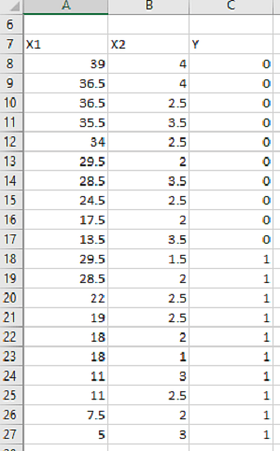
Data shown above consists of three variables where X1 and X2 are independent variables and Y is a class variable. We have kept only 2 categories for our purpose of binary logistic regression classifier.
Next we have to create a logit function using independent variables, i.e.
Logit = L = β₀ + β₁*X₁ + β₂*X₂
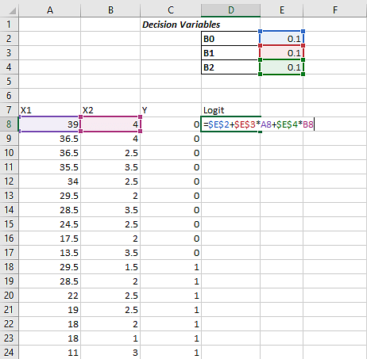
We have kept the initial values of beta 1, beta 2 as 0.1 for now and we will use Excel Solve to optimize the beta values in order to maximize our log likelihood estimate.
Assuming that you are aware of logistic regression basics, we calculate probability values from Logit using following formula:
Probability= e^Logit/(1+ e^Logit )
e is base of natural logarithm i.e. e = 2.71828163
Let’s put it into excel formula to calculate probability values for each of the observation.

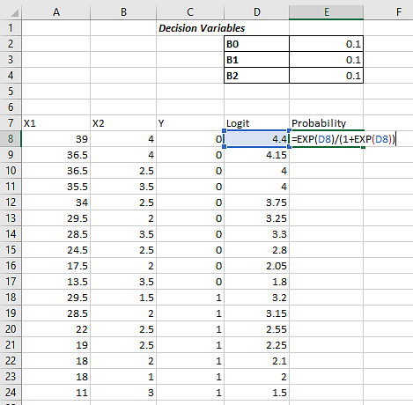
The conditional probability is the probability of Predicted Y, given set of independent variables X.
And this p can be calculated as-
P〖(X)〗^Yactual*[1-P〖(X)〗^(1-Yactual)]
Then we have to take natural log of the above function-
ln⁡〖[ 〗 P〖(X)〗^Yactual*[1-P(X)^(1-Yactual) ]]
Which turns out to be –
Yactual*ln⁡〖[ 〗 P(X)]*(Yactual- 1)*ln[1-P(X)]
Log likelihood function LL is the sum of above equation for all the observations
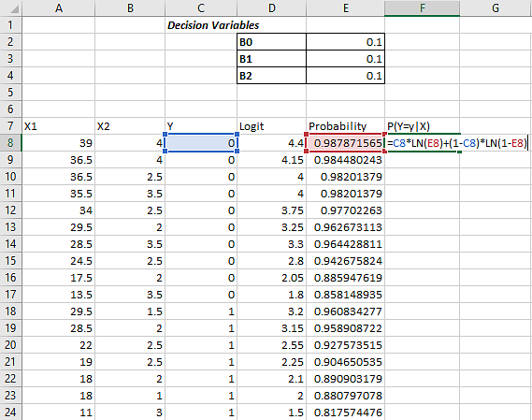
Log likelihood LL will be sum of column G, which we just calculated
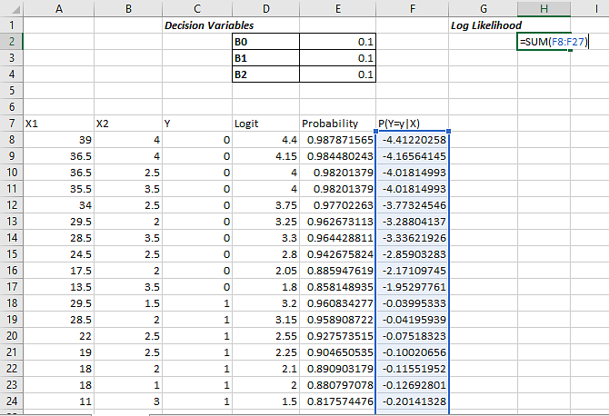
The objective is to maximize the Log Likelihood i.e. cell H2 in this example. We have to maximize H2 by optimizing B₀, B₁, and B_{2.}
We’ll use Excel’s solver add-in to achieve the same.
Excel comes with this Add-in pre-installed and you must see it under Data Tab in Excel as shown below
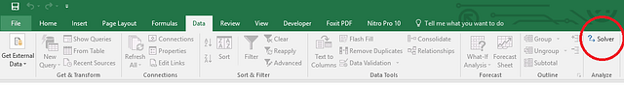
If you don’t see it there then make sure if you have loaded it. To load an add-in in Excel,
Go to File >> Options >> Add-Ins and see if checkbox in front of required add-in is checked or not? Make sure to check it to load an add-in into Excel.
If you don’t see Solver Add-in there, go to the bottom of the screen (Manage Add-Ins) and click on OK. Next you will see a popup window which should have your Solver add-in present. Check the checkbox in-front of the add-in name. If you don’t see it there as well click on browse and direct it to the required folder which contains Solver Add-In.
Once you have your Solver loaded, click on Solver icon under Data tab and You will see a new window popped up like –

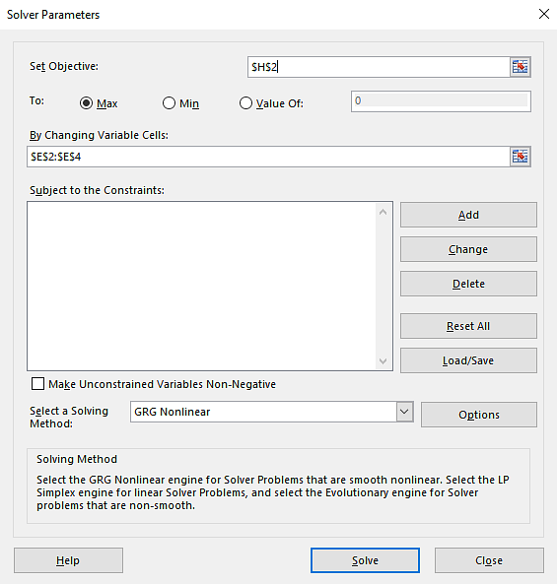
Put H2 in set objective, select max and fill cells E2 to E4 in next form field.
By doing this we have told Solver to Maximize H2 by changing values in cells E2 to E4.
Now click on Solve button at the bottom –
You will see a popup like below -
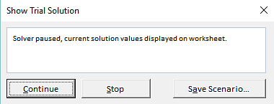

This shows that Solver has found a local maxima solution but we are in need of Global Maxima Output. Keep clicking on Continue until it shows the below popup
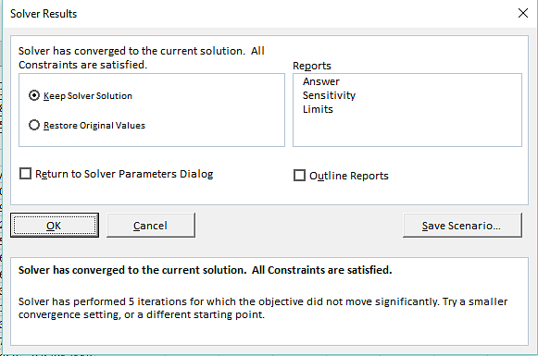
It shows that Solver was able to find and converge the solution. In case it is not able to converge it will throw an error. Select “Keep Solver Solution” and Click on OK to accept the solution provided by Solver.
Now, you can see that value of Beta coefficients from B_{0,} B₁ B₂ have changed and our Log Likelihood function has been maximized.
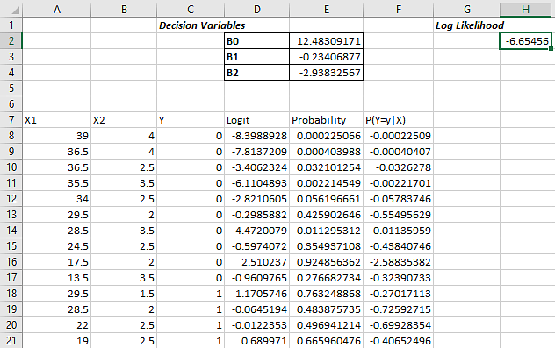
Using these values of Betas you can calculate the probability and hence response variable by deciding the probability cut-off.

51) What do you understand by Fuzzy merging ? Which language will you use to handle it?
52) What is the difference between skewed and uniform distribution?
When the observations in a dataset are spread equally across the range of distribution, then it is referred to as uniform distribution. There are no clear perks in an uniform distribution. Distributions that have more observations on one side of the graph than the other are referred to as skewed distribution.Distributions with fewer observations on the left ( towards lower values) are said to be skewed left and distributions with fewer observation on the right ( towards higher values) are said to be skewed right.
53) You created a predictive model of a quantitative outcome variable using multiple regressions. What are the steps you would follow to validate the model?
Since the question asked, is about post model building exercise, we will assume that you have already tested for null hypothesis, multi collinearity and Standard error of coefficients.
Once you have built the model, you should check for following –
· Global F-test to see the significance of group of independent variables on dependent variable
· R^2
· Adjusted R^2
· RMSE, MAPE
In addition to above mentioned quantitative metrics you should also check for-
· Residual plot
· Assumptions of linear regression
54) What do you understand by Hypothesis in the content of Machine Learning?
55) What do you understand by Recall and Precision?
Recall measures "Of all the actual true samples how many did we classify as true?"
Precision measures "Of all the samples we classified as true how many are actually true?"
We will explain this with a simple example for better understanding -
Imagine that your wife gave you surprises every year on your anniversary in last 12 years. One day all of a sudden your wife asks -"Darling, do you remember all anniversary surprises from me?".
This simple question puts your life into danger.To save your life, you need to Recall all 12 anniversary surprises from your memory. Thus, Recall(R) is the ratio of number of events you can correctly recall to the number of all correct events. If you can recall all the 12 surprises correctly then the recall ratio is 1 (100%) but if you can recall only 10 suprises correctly of the 12 then the recall ratio is 0.83 (83.3%).
However , you might be wrong in some cases. For instance, you answer 15 times, 10 times the surprises you guess are correct and 5 wrong. This implies that your recall ratio is 100% but the precision is 66.67%.
Precision is the ratio of number of events you can correctly recall to a number of all events you recall (combination of wrong and correct recalls).
56) How will you find the right K for K-means?
57) Why L1 regularizations causes parameter sparsity whereas L2 regularization does not?
Regularizations in statistics or in the field of machine learning is used to include some extra information in order to solve a problem in a better way. L1 & L2 regularizations are generally used to add constraints to optimization problems.

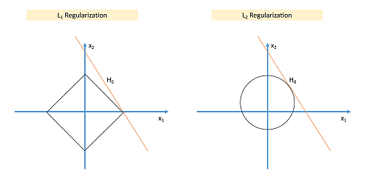
In the example shown above H₀ is a hypothesis. If you observe, in L₁ there is a high likelihood to hit the corners as solutions while in L₂, it doesn’t. So in L₁ variables are penalized more as compared to L2 which results into sparsity.
In other words, errors are squared in L₂, so model sees higher error and tries to minimize that squared error.
58) How can you deal with different types of seasonality in time series modelling? (get 100+ solved code examples here)
Seasonality in time series occurs when time series shows a repeated pattern over time. E.g., stationary sales decreases during holiday season, air conditioner sales increases during the summers etc. are few examples of seasonality in a time series.
Seasonality makes your time series non-stationary because average value of the variables at different time periods. Differentiating a time series is generally known as the best method of removing seasonality from a time series. Seasonal differencing can be defined as a numerical difference between a particular value and a value with a periodic lag (i.e. 12, if monthly seasonality is present)
59) Explain evaluation protocols for testing your models? Compare hold-out vs k-fold cross validation vs iterated k-fold cross-validation methods of testing.
60) What do you understand by conjugate-prior with respect to Naïve Bayes?
61) Can you cite some examples where a false positive is important than a false negative?
Before we start, let us understand what are false positives and what are false negatives.
False Positives are the cases where you wrongly classified a non-event as an event a.k.a Type I error.
And, False Negatives are the cases where you wrongly classify events as non-events, a.k.a Type II error.
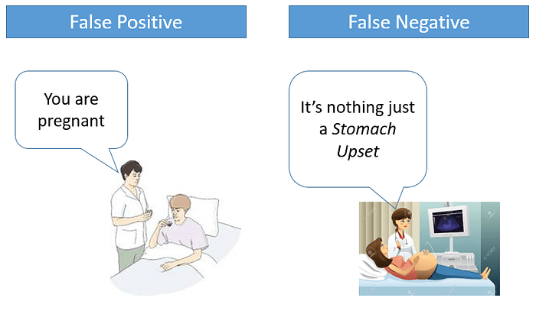
In medical field, assume you have to give chemo therapy to patients. Your lab tests patients for certain vital information and based on those results they decide to give radiation therapy to a patient.
Assume a patient comes to that hospital and he is tested positive for cancer (But he doesn’t have cancer) based on lab prediction. What will happen to him? (Assuming Sensitivity is 1)
One more example might come from marketing. Let’s say an ecommerce company decided to give $1000 Gift voucher to the customers whom they assume to purchase at least $5000 worth of items. They send free voucher mail directly to 100 customers without any minimum purchase condition because they assume to make at least 20% profit on sold items above 5K.
Now what if they have sent it to false positive cases?
62) Can you cite some examples where a false negative important than a false positive? (get 100+ solved code examples here)
Assume there is an airport ‘A’ which has received high security threats and based on certain characteristics they identify whether a particular passenger can be a threat or not. Due to shortage of staff they decided to scan passenger being predicted as risk positives by their predictive model.
What will happen if a true threat customer is being flagged as non-threat by airport model?
Another example can be judicial system. What if Jury or judge decide to make a criminal go free?
What if you rejected to marry a very good person based on your predictive model and you happen to meet him/her after few years and realize that you had a false negative?
63) Can you cite some examples where both false positive and false negatives are equally important?
In the banking industry giving loans is the primary source of making money but at the same time if your repayment rate is not good you will not make any profit, rather you will risk huge losses.
Banks don’t want to lose good customers and at the same point of time they don’t want to acquire bad customers. In this scenario both the false positives and false negatives become very important to measure.
These days we hear many cases of players using steroids during sport competitions Every player has to go through a steroid test before the game starts. A false positive can ruin the career of a Great sportsman and a false negative can make the game unfair.
Get hands-on experience for your interviews with free access to solved code examples found here (these are ready-to-use for your projects)
64) Can you explain the difference between a Test Set and a Validation Set?
Validation set can be considered as a part of the training set as it is used for parameter selection and to avoid Overfitting of the model being built. On the other hand, test set is used for testing or evaluating the performance of a trained machine leaning model.
In simple terms ,the differences can be summarized as-
- Training Set is to fit the parameters i.e. weights.
- Test Set is to assess the performance of the model i.e. evaluating the predictive power and generalization.
- Validation set is to tune the parameters.
65) What makes a dataset gold standard?
66) What do you understand by statistical power of sensitivity and how do you calculate it?
Sensitivity is commonly used to validate the accuracy of a classifier (Logistic, SVM, RF etc.). Sensitivity is nothing but “Predicted TRUE events/ Total events”. True events here are the events which were true and model also predicted them as true.
Calculation of senstivity is pretty straight forward-
Senstivity = True Positives /Positives in Actual Dependent Variable
Where, True positives are Positive events which are correctly classified as Positives.
67) What is the importance of having a selection bias? (get 100+ solved code examples here)
Selection Bias occurs when there is no appropriate randomization achieved while selecting individuals, groups or data to be analyzed. Selection bias implies that the obtained sample does not exactly represent the population that was actually intended to be analyzed. Selection bias consists of Sampling Bias, Data, Attribute, and Time Interval.
68) Given that you let the models run long enough, will all gradient descent algorithms lead to the same model when working with Logistic or Linear regression problems?
69) Differentiate between Batch Gradient Descent, Mini-Batch Gradient Descent, and Stochastic Gradient Descent.
70) How do data management procedures like missing data handling make selection bias worse?
Missing value treatment is one of the primary tasks which a data scientist is supposed to do before starting data analysis. There are multiple methods for missing value treatment. If not done properly, it could potentially result in selection bias. Let see few missing value treatment examples and their impact on selection-
Complete Case Treatment: Complete case treatment is when you remove an entire row in data even if one value is missing. You could achieve a selection bias if your values are not missing at random and they have some pattern. Assume you are conducting a survey and few people didn’t specify their gender. Would you remove all those people? Can’t it tell a different story?
Available case analysis: Let say you are trying to calculate a correlation matrix for data so you might remove the missing values from variables that are needed for that particular correlation coefficient. In this case, your values will not be fully correct as they are coming from population sets.
Mean Substitution: In this method, missing values are replaced with the mean of other available values. This might make your distribution biased e.g., standard deviation, correlation and regression are mostly dependent on the mean value of variables.
Hence, various data management procedures might include selection bias in your data if not chosen correctly.
71) What are the advantages and disadvantages of using regularization methods like Ridge Regression?
72) What do you understand by long and wide data formats?
73) What do you understand by outliers and inliers? What would you do if you find them in your dataset?
74) Write a program in Python that takes input as the diameter of a coin and weight of the coin and produces output as the money value of the coin.
75) What are the basic assumptions to be made for linear regression? (get sample code here)
Normality of error distribution, statistical independence of errors, linearity and additivity.
76) Can you write the formula to calculate R-square?
R-Square can be calculated using the below formular -
1 - (Residual Sum of Squares/ Total Sum of Squares)
77) What is the advantage of performing dimensionality reduction before fitting an SVM?
Support Vector Machine Learning Algorithm performs better in the reduced space. It is beneficial to perform dimensionality reduction before fitting an SVM if the number of features is large when compared to the number of observations.
78) How will you assess the statistical significance of an insight whether it is a real insight or just by chance?
Statistical importance of an insight can be accessed using Hypothesis Testing.
79) How would you create a taxonomy to identify key customer trends in unstructured data?
Tweet: Data Science Interview questions #1 - How would you create a taxonomy to identify key customer trends in unstructured data? - http://ctt.ec/sdqZ0+
The best way to approach this question is to mention that it is good to check with the business owner and understand their objectives before categorizing the data. Having done this, it is always good to follow an iterative approach by pulling new data samples and improving the model accordingly by validating it for accuracy by soliciting feedback from the stakeholders of the business. This helps ensure that your model is producing actionable results and improving over the time.
80) How will you find the correlation between a categorical variable and a continuous variable ?
You can use the analysis of covariance technqiue to find the correlation between a categorical variable and a continuous variable.
81) Is it better to have too many false negatives or too many false positives?
82) In experimental design, is it necessary to do randomization? If yes, why?
83) What are the benefits of using a convolutional neural network over a fully connected network when working with image classification problems?
84) What are the benefits of using a recurrent neural network over a fully connected network when working with text data?
85) What do you understand by feature vectors?
86) How can outlier values be treated?
Outlier values can be identified by using univariate or any other graphical analysis method. If the number of outlier values is few then they can be assessed individually but for a large number of outliers, the values can be substituted with either the 99th or the 1st percentile values. All extreme values are not outlier values. The most common ways to treat outlier values –
1) To change the value and bring in within a range
2) To just remove the value.
87) How can you assess a good logistic model?
There are various methods to assess the results of logistic regression analysis-
• Using Classification Matrix to look at the true negatives and false positives.
• Concordance that helps identify the ability of the logistic model to differentiate between the event happening and not happening.
• Lift helps assess the logistic model by comparing it with random selection.
88) What are categorical variables?
89) What is the benefit of weight initialization in neural networks?
90) How does the use of dropout work as a regularizer for deep neural networks?
91) How beneficial is dropout regularization in deep learning models? Does it speed up or slow down the training process and why?
92) How will you explain logistic regression to an economist, physician-scientist, and biologist?
93) What is the benefit of batch normalization?
94) Give some situations where you will use an SVM over a RandomForest Machine Learning algorithm and vice-versa.
95) What is multicollinearity and how you can overcome it?
SVM and Random Forest are both used in classification problems.
a) If you are sure that your data is outlier free and clean then go for SVM. It is the opposite - if your data might contain outliers then Random forest would be the best choice
b) Generally, SVM consumes more computational power than Random Forest, so if you are constrained with memory go for the Random Forest machine learning algorithm.
c) Random Forest gives you a very good idea of variable importance in your data, so if you want to have variable importance then choose the Random Forest machine learning algorithm.
d) Random Forest machine learning algorithms are preferred for multiclass problems.
e) SVM is preferred in multi-dimensional problem set - like text classification
but as a good data scientist, you should experiment with both of them and test for accuracy, or rather you can use an ensemble of many Machine Learning techniques.
96) What is the curse of dimensionality?
97) Do you need to do feature engineering and feature extraction when applying deep learning models?
98) How will you calculate the accuracy of a model using a confusion matrix?
99) According to the universal approximation theorem, any function can be approximated as closely as required using single collinearity. Then why people use more?
100) Explain the use of Combinatorics in data science.
101) You are given a dataset with 1500 observations and 15 features. How many observations you will select in each decision tree in a random forest?
Each decision tree has a subset of features but includes all the observations from the dataset. In this case, the answer will be 1500 as the tree will include all the observations from the dataset.
102) How will you evaluate the performance of a logistic regression model?
It's very much obvious that you would mention accuracy as the answer to this question but since logistic regression is not the same as linear regression it will mislead. You should mention how you will use the confusion matrix to evaluate the performance and the various statistics related to it like Precision, Specificity, Sensitivity, or Recall. You get bonus points for mentioning Concordance, Discordance, and AUC.
Data Science Puzzles-Brain Storming/ Puzzle based Data Science Interview Questions asked in Data Scientist Job Interviews
1) How many Piano Tuners are there in Chicago?
To solve this kind of problem, we need to know –
Can you tell if the equation given below is linear or not?
Emp_sal= 2000+2.5(emp_age)²
Yes it is a linear equation as the coefficients are linear.
What will be the output of the following R programming code ?
var2<- c("I","Love,"ProjectPro")
var2
It will give an error.
How many Pianos are there in Chicago?
How often would a Piano require tuning?
How much time does it take for each tuning?
We need to build these estimates to solve this kind of a problem. Suppose, let’s assume Chicago has close to 10 million people and on an average there are 2 people in a house. For every 20 households there is 1 Piano. Now the question how many pianos are there can be answered. 1 in 20 households has a piano, so approximately 250,000 pianos are there in Chicago.
Now the next question is-“How often would a Piano require tuning? There is no exact answer to this question. It could be once a year or twice a year. You need to approach this question as the interviewer is trying to test your knowledge on whether you take this into consideration or not. Let’s suppose each piano requires tuning once a year so on the whole 250,000 piano tunings are required.
Let’s suppose that a piano tuner works for 50 weeks in a year considering a 5 day week. Thus a piano tuner works for 250 days in a year. Let’s suppose tuning a piano takes 2 hours then in an 8 hour workday the piano tuner would be able to tune only 4 pianos. Considering this rate, a piano tuner can tune 1000 pianos a year.
Thus, 250 piano tuners are required in Chicago considering the above estimates.
2) There is a race track with five lanes. There are 25 horses of which you want to find out the three fastest horses. What is the minimal number of races needed to identify the 3 fastest horses of those 25?
Divide the 25 horses into 5 groups where each group contains 5 horses. Race between all the 5 groups (5 races) will determine the winners of each group. A race between all the winners will determine the winner of the winners and must be the fastest horse. A final race between the 2nd and 3rd place from the winners group along with the 1st and 2nd place of thee second place group along with the third place horse will determine the second and third fastest horse from the group of 25.
3) Estimate the number of french fries sold by McDonald's everyday.
4) How many times in a day does a clock’s hand overlap?
5) You have two beakers. The first beaker contains 4 litre of water and the second one contains 5 litres of water.How can you our exactly 7 litres of water into a bucket?
6) A coin is flipped 1000 times and 560 times heads show up. Do you think the coin is biased?
7) Estimate the number of tennis balls that can fit into a plane.
8) How many haircuts do you think happen in US every year?
9) In a city where residents prefer only boys, every family in the city continues to give birth to children until a boy is born. If a girl is born, they plan for another child. If a boy is born, they stop. Find out the proportion of boys to girls in the city.

Probability Interview Questions for Data Science
- There are two companies manufacturing electronic chip. Company A is manufactures defective chips with a probability of 20% and good quality chips with a probability of 80%. Company B manufactures defective chips with a probability of 80% and good chips with a probability of 20%.If you get just one electronic chip, what is the probability that it is a good chip?
- Suppose that you now get a pack of 2 electronic chips coming from the same company either A or B. When you test the first electronic chip it appears to be good. What is the probability that the second electronic chip you received is also good?
- A dating site allows users to select 6 out of 25 adjectives to describe their likes and preferences. A match is said to be found between two users on the website if the match on atleast 5 adjectives. If Steve and On a dating site, users can select 5 out of 24 adjectives to describe themselves. A match is declared between two users if they match on at least 4 adjectives. If Brad and Angelina randomly pick adjectives, what is the probability that they will form a match?
- A coin is tossed 10 times and the results are 2 tails and 8 heads. How will you analyze whether the coin is fair or not? What is the p-value for the same?
- Continuation to the above question, if each coin is tossed 10 times (100 tosses are made in total). Will you modify your approach to test the fairness of the coin or continue with the same?
- An ant is placed on an infinitely long twig. The ant can move one step backward or one step forward with the same probability during discrete time steps. Find out the probability with which the ant will return to the starting point.

Statistics Interview Questions for Data Science
1. Explain the central limit theorem.
2. What is the relevance of the central limit theorem to a class of freshmen in the social sciences who hardly have any knowledge about statistics?
3. Given a dataset, show me how Euclidean Distance works in three dimensions.
4. How will you prevent overfitting when creating a statistical model?

Python Data Science Interview Questions
1) Explain about the range function.
2) How can you freeze an already built machine learning model for later use ? What is the command you would use?
3) Differentiate between func anf func()
4) Write the command to import a decision tree classification algorithm using sklearn library.
5) What do you understand by pickling in Python?

Frequently Asked Open-Ended Machine Learning Interview Questions for Data Scientists
- Which is your favorite machine learning algorithm and why?
- In which libraries for Data Science in Python and R, does your strength lie?
- What kind of data is important for specific business requirements and how, as a data scientist will you go about collecting that data?
- Tell us about the biggest data set you have processed to date and for what kind of analysis.
- Which data scientists you admire the most and why?
- Suppose you are given a data set, what will you do with it to find out if it suits the business needs of your project or not.
- What were the business outcomes or decisions for the projects you worked on?
- What unique skills you think can you add to our data science team?
- Which are your favorite data science startups?
- Why do you want to pursue a career in data science?
- What have you done to upgrade your skills in analytics?
- What has been the most useful business insight or development you have found?
- How will you explain an A/B test to an engineer who does not know statistics?
- When does parallelism helps your algorithms run faster and when does it make them run slower?
- How can you ensure that you don’t analyze something that ends up producing meaningless results?
- How would you explain to the senior management in your organization why a particular data set is important?
- Is more data always better?
- What are your favorite imputation techniques to handle missing data?
- What are your favorite data visualization tools?
- Explain the life cycle of a data science project.
- What according to you are the limitations of deep learning?

Suggested Answers by Data Scientists for Open-Ended Data Science Interview Questions
How can you ensure that you don’t analyze something that ends up producing meaningless results?
- Understanding whether the model chosen is correct or not. Start understanding from the point where you did Univariate or Bivariate analysis, analyzed the distribution of data and correlation of variables and built the linear model. Linear regression has an inherent requirement that the data and the errors in the data should be normally distributed. If they are not then we cannot use linear regression. This is an inductive approach to find out if the analysis using linear regression will yield meaningless results or not.
- Another way is to train and test data sets by sampling them multiple times. Predict on all those datasets to find out whether or not the resultant models are similar and are performing well.
- By looking at the p-value, by looking at r square values, by looking at the fit of the function and analyzing as to how the treatment of missing value could have affected- data scientists can analyze if something will produce meaningless results or not.
- Gaganpreet Singh, Data Scientist
So, there you have over 120 data science interview questions and answers for most of them too. These are some of the more common interview questions for data scientists around data, statistics, and data science that can be asked in the interviews. We will come up with more questions – specific to language, Python/ R, in the subsequent articles, and fulfill our goal of providing 120 data science interview questions PDF with answers to our readers.

3 Secrets to becoming a Great Enterprise Data Scientist
• Keep on adding technical skills to your data scientist’s toolbox.
• Improve your scientific axiom
• Learn the language of business as the insights from a data scientist help in reshaping the entire organization.
The important tip, to nail a data science interview is to be confident with the answers without bluffing. If you are well-versed with a particular technology whether it is Python, R, Hadoop, Spark or any other big data technology ensure that you can back this up but if you are not strong in a particular area do not mention it unless asked about it. The above list of data scientist job interview questions is not an exhaustive one. Every company has a different approach to interviewing data scientists. However, we do hope that the above data science technical interview questions elucidate the data science interview process and provide an understanding of the type of data scientist job interview questions asked when companies are hiring data people.
We request industry experts and data scientists to chime in their suggestions in comments for open-ended data science interview questions to help students understand the best way to approach the interviewer and help them nail the interview.

